While she sleeps webstore

NEA Project

4205

Richard Burney

Contents

Analysis 2

The Problem Definition 2

Background research 2

Description of Current System: 3

Identification of End Users/Players 4

Objectives 4

Design 6

Core Functions 6

Algorithms 7

User Interface 8

SQL Queries 8

Framework 12

Security and Validation 12

Flow Charts 12

Entity Relationship Diagram 14

Data Dictionary 16

Data Flow 18

Testing 19

Test Strategy 20

Testing video 22

Test Table 23

User Feedback 25

Analysis of User Feedback 26

Evaluation 26

Technical Solution 30

Backend Files 30

Index pages 44

User Pages 49

Admin Pages 55

Store Pages 62

# Analysis

## The Problem Definition

* A website is a series of pages linked together for the ease of use for the user. A website has become the best way of marketing, sharing information, shopping and much, much more. Websites are used by millions of different companies for all of their different needs. Whether it is selling goods, advertising pubs or a way to tell your employees their shift times for the following weeks, websites are used. For example, a website could be used for a small, freelancing start-up, to help broaden their client base by using ads leading directly to their website (so the client can see what the company is cable able of) rather than just an email or phone number, meaning there is no way to see the companies’ previous work. Websites can also be useful for accessing databases on the go, such as inventory, so managers can find out what they need to stock up on from anywhere in the world.
* A website can be the single, most important tool for a band, as it is a way to get their music out there, list the concerts they are playing and allow their fans to buy their merchandise.
* A bad website can lead to fans being misinformed or even losing their orders. This emphasis on websites, will only increase as the world becomes even more digital; to be successful without a website is now harder than ever. The ease of having a website to the end user is astronomical, being able to access it anywhere, on any device, every day of the year.

## Background research

* Most dedicated band websites have a few similar parts to their websites; tours, store, a page about their music and page about themselves. Also, some of these bands have different store for different parts of the world, ie. Us and eu. In addition to this, many store websites have a most popular bought items page that has the most frequently bought items on it. Specifically, the While She Sleeps website is mainly used as a store and the band, themselves, is the secondary function of the website. Only 3 out the 10 tabs of the top of the page are not part of the store. These websites also provide a way for people that would have to travel far to see a show to be able to buy merchandise as they would not be able to go to a show to buy some there.
* Other shop websites have similar features, such as saving the users cart when they go offline, saving the users address and payment details. These websites also have the homepage where the most popular items are shown, to increase the chance of the user buying from the store.

## Description of Current System:

* + There are quite a few websites that are dedicated to website building. These have templates that you can follow to create your website also these websites can sell domain names. These websites require monthly payments rather than a big one-time payment, like a regular website creator would, but on the plus side nothing needs to be update manually by the user as the websites does all of that for you. However, the problem with these website builders is that you do now have the freedom to do what you want with your website, or what you need to. These builders might not have the needs you require for your website. Also, if you pay someone to build you a website, it is a one-time payment so recurring payments cannot come back to haunt you.
  + There are many websites with a store selling ‘While She Sleeps’ merchandise, including their official website. But the information of the band can only be found on Wikipidea, which can be edited by anyone so it is not completely reliable. In all of these stores, it is difficult to tell what is official and what is not. Also the profits of the merchandise would not go to the band but a third party company that has no relation to the band.

## Identification of End Users/Players

* + The end use would be a fan of the band looking to find out more info on the band or looking to buy some merchandise of the band. A user might be looking into what shows the band are playing next, or what other music they have made. However, the main purpose of the website is to sell their merchandise, and the user would use this website to look through all that the band is offering and decide what they would like to buy. The user could also access the website on their phone, making it even easier to use the website on the move as everyone has a phone so anyone can access the website at all times, from anywhere. The age range of the customers would be late teen to adult as this would be the age range that listens to the band’s music. Also the band and management staff would use the website to add to the store and to the shows list. They would also be able to see what items from the store are running low on stock.

## Objectives

* + Have a functioning profile system that can be updated by the user
  + Have a store that can be used by the user to buy merchandise
  + Have the store pull the address from the user’s profile but asks whether it is right
  + Have a most popular page on the store that is automatically updated with the items that have been bought the most
  + Have an easily updatable shows page that takes off a show when it has been finished automatically
  + Have the shows page be updated by an admin user that can access other parts of the website
  + Have tweets from their official twitter integrated into the website
  + Be able to pull items from the different categories into the cart
  + Have a clean UI that is easy to understand so people can easily navigate around the website
  + Have an admin page that can be used to manage the shows page, the store and orders.
  + Remember the cart for a specific user when the user closes the website or it is restarted
  + Let a user delete their account
  + Have the website show all necessary information on the band
  + Have a page to view previous orders with amount spent and items bought
  + Have a page that can show the ongoing orders and show how far along in its journey it is ie. Shipped, delivered or processing
  + Have levels of access granted to different people ie. Admin, Owner, regular user
  + Have a page where the owner can change the permissions of the other users
  + On the admin page let the admin add shows or edit shows
  + On the admin page let the admin add stock to existing items or add a new item to the store.
  + Allow an admin to put an item on sale
  + Allow an admin to see all the orders that aren’t delivered. And to be able to change the status of specific orders. When an order is changed to delivered, it will disappear from the table.
  + Have email notifications for shows that are coming in a specific area.

# 

# Design

## Core Functions

* A place where fans of the band can come and find out what shows the band will be playing.
  + The website displays all of the future shows that the band is playing with the location, venue and the date of the show. Every time someone enters this page the website checks whether any of the shows is in the past, and if it is then it is deleted from the database and is not displayed. This is to make sure that there is no confusion for the users when deciding whether to attend a show or not.
* A place where fans can buy official band merchandise
  + The website has a page where all the band merchandise can be bought. There are also sub sections for each category such as men’s/women’s/outwear. From this page the user can also access their cart, which is saved even when the user is not logged in. When a user clicks on an item, a specific item page appears where images of the items are displayed with the stock of each size and the size. From this page a user can add a number of items to their cart and from their cart remove them again if needed. And if not, the user can checkout from here where they have to confirm their address and card details and then order said items.
* A portal for admins and owners
  + For admins, this is a place where an admin is able to view all of the items in the store and how profitable each item is. With also the total profitability of the website. One of the tabs is the orders page, here an admin can see all the orders made by users, also on this page an admin can update the order status. Next is the stock section of the admin page, here it shows all of the stock and here an admin can top up the stock of a specific item or add a new item to the store. The final part of the admin section is the shows page, where an admin can view all of the shows, add a new show or edit an existing show. For owners, they still have access to the admin section but also to the user access section, here an owner can see all the users register on the website and can change their access level from here.
* A portal where admins can see all sales analytics for each item
  + This is a page where all admins of the site can see a table that shows each item; how many are in stock, how many are sold, how much each item costs to make, profit and how much they sell for. It also shows the collective profit for each item, so the admins know which items are selling the best and which are making the most/least profit. This is useful because it helps the admins know which items they need to be advertising and how much stock would be needed for a new version of an item,
* A profile page for all users
  + This is a page that ever use has. Here the user can see all of the data that the website stores. They can also edit their profile, delete their account or logout. There is also a link to the user’s order page.
* A place where users can view all their orders
  + Here every user can access their orders active or not and no matter how old. They are ordered by date. It shows the date, the items, the quantity and the cost of the orders.

## Algorithms

* The create user algorithm checks that you enter a username, email and password when creating your account. It also checks whether anybody else has used the same username or email and if they have it tells you to choose a different username/email. This data is then added to the User database and it means that the user can login whenever they choose. It also means that the user can easily update the information stored on them when needed. If they so choose, the user can also delete their account, which deletes the whole entry in the database but not their orders which are saved for statistical purposes.
* The email notifications algorithm allows the user to add a place where if show is happening, they get an email about it. Their user enters the place in which they would like the emails about, then the website stores this in the Email_not database along with the users ID. When a show is created, the website checks all of the entries on the Email_not database for a match, and if there is it pulls out the user’s email and sends them an email with the details of the show.
* The add to cart function allows the user to add a certain item to their shopping cart. This checks whether the same item is already in the cart but checking the stock_id and if it is, then it adds “1” to the quantity in the cart, if it is not in the cart, then it will add the item to the cart database along with the stock_id, item_id and user_id. The opposite of this the removing an item from the cart. This checks how many of the item is in the cart, if it is 2 or more, it just removes 1 from the quantity in the database. But if the quantity is 1, then it removes the item from the cart entirely.
* The add show and edit shows function just allows a user to add or edit data in the Concerts database. Basic but works as intended.
* The delete shows algorithm works by every time someone enters the shows page, it checks the current date and compares it to the date of the show and if the date of the show is in the past, it deletes the show from the database. It the date is in the future or the same as the current date, it is left alone.
* The add to store algorithm allows the user to add an item to the store but it checks whether there is already an item with the same ID and/or name. If there is then a new ID will be made, but if not, then the item is just added to the store and stock databases respectively.
* The sales analytics algorithm pulls data from the stock database to calculate the overall cost and profit for each item as well as the total profit of each items. This is then displayed on a table in the Admin Tools so that admins can easily find out which items are making the most profit and which are making the least.

## User Interface

* I have chosen to have a graphical interface for my website instead of a command-line interface as a command-line interface would not fit a website environment. On my website my main source of navigation will be a navigation bar at the top of the page which leads to the main pages of the website, such as the store, music and a profile page. I will also make it easy for users/admins to change aspects of what data the website stores ie. User data of Store item data. There is also a separate navigation bar for the store that have links to store specific pages such as men’s/women’s, but also has a link back to the main page of the website where all other aspects of the website can be accessed. In the admin tools section, which is accessible from the profile to applicable users, there is a secondary navbar which shows all of the sections of the admin tools. I thought this was necessary so it is easy to navigate for the user. In the admin/owner section, there is another navigation bar which is displayed under the first one. This gives links to all of the tools available to the user, I have done this so it is easy for an admin to navigate through these pages meaning they can have a higher workflow.

## SQL Queries

* Queries are filtered to only show the appropriate data, for example a query into the User database to find all the Usernames, would not return the usernames and emails, only the usernames. Quires like this are used on most pages on the website. I have chosen to use this type of query because they are fast and accurate and are simple to execute/troubleshoot. The tables in my database are organised so that the least amount of complex queries have to be used, as they are the element that is most likely to go wrong, and in a place where users’ sensitive data such as addresses and emails are stored and error could be catastrophic. Most of the SQL Queries performed are done so in the html files, this is because it makes it easy to diagnose and fix a problem, also if there is a big problem occurring, it makes it easy to isolate it without affecting other parts of the website.

Main Page

Design:

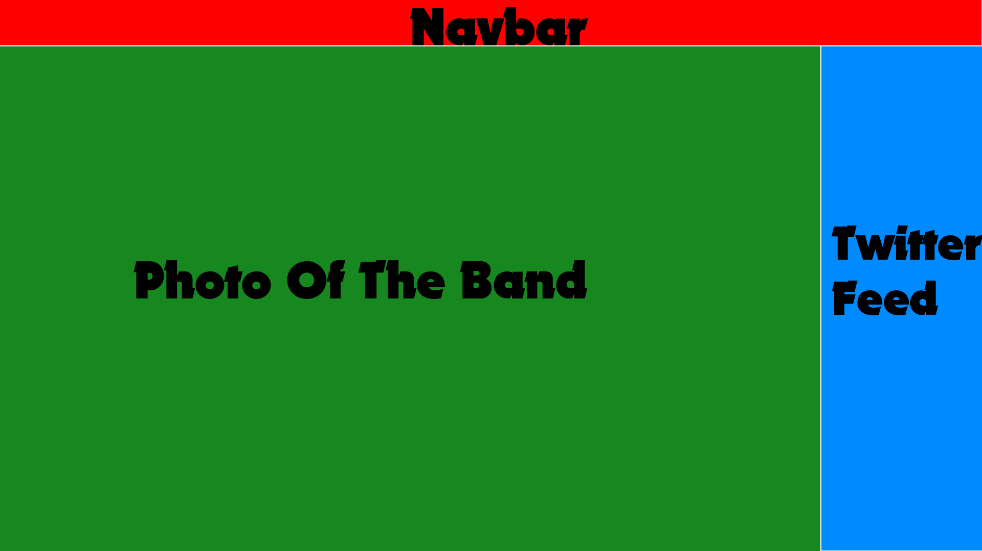

Outcome:

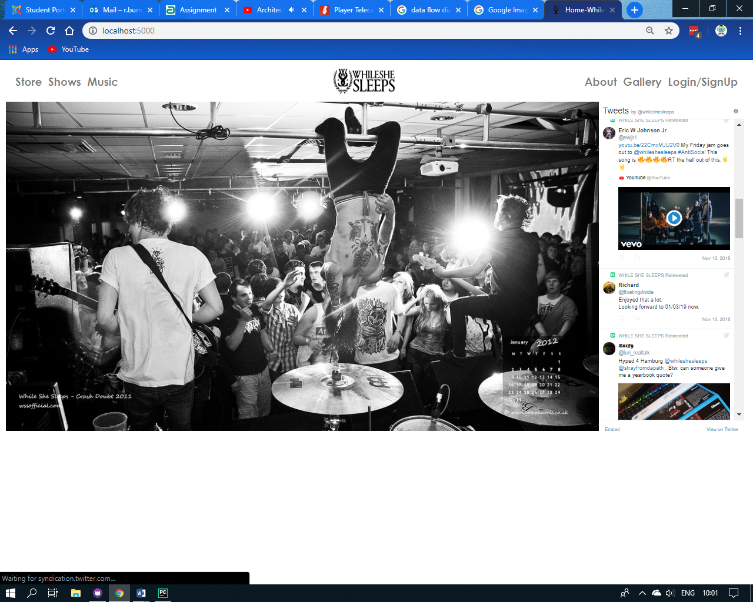

S

tore Page

Design: 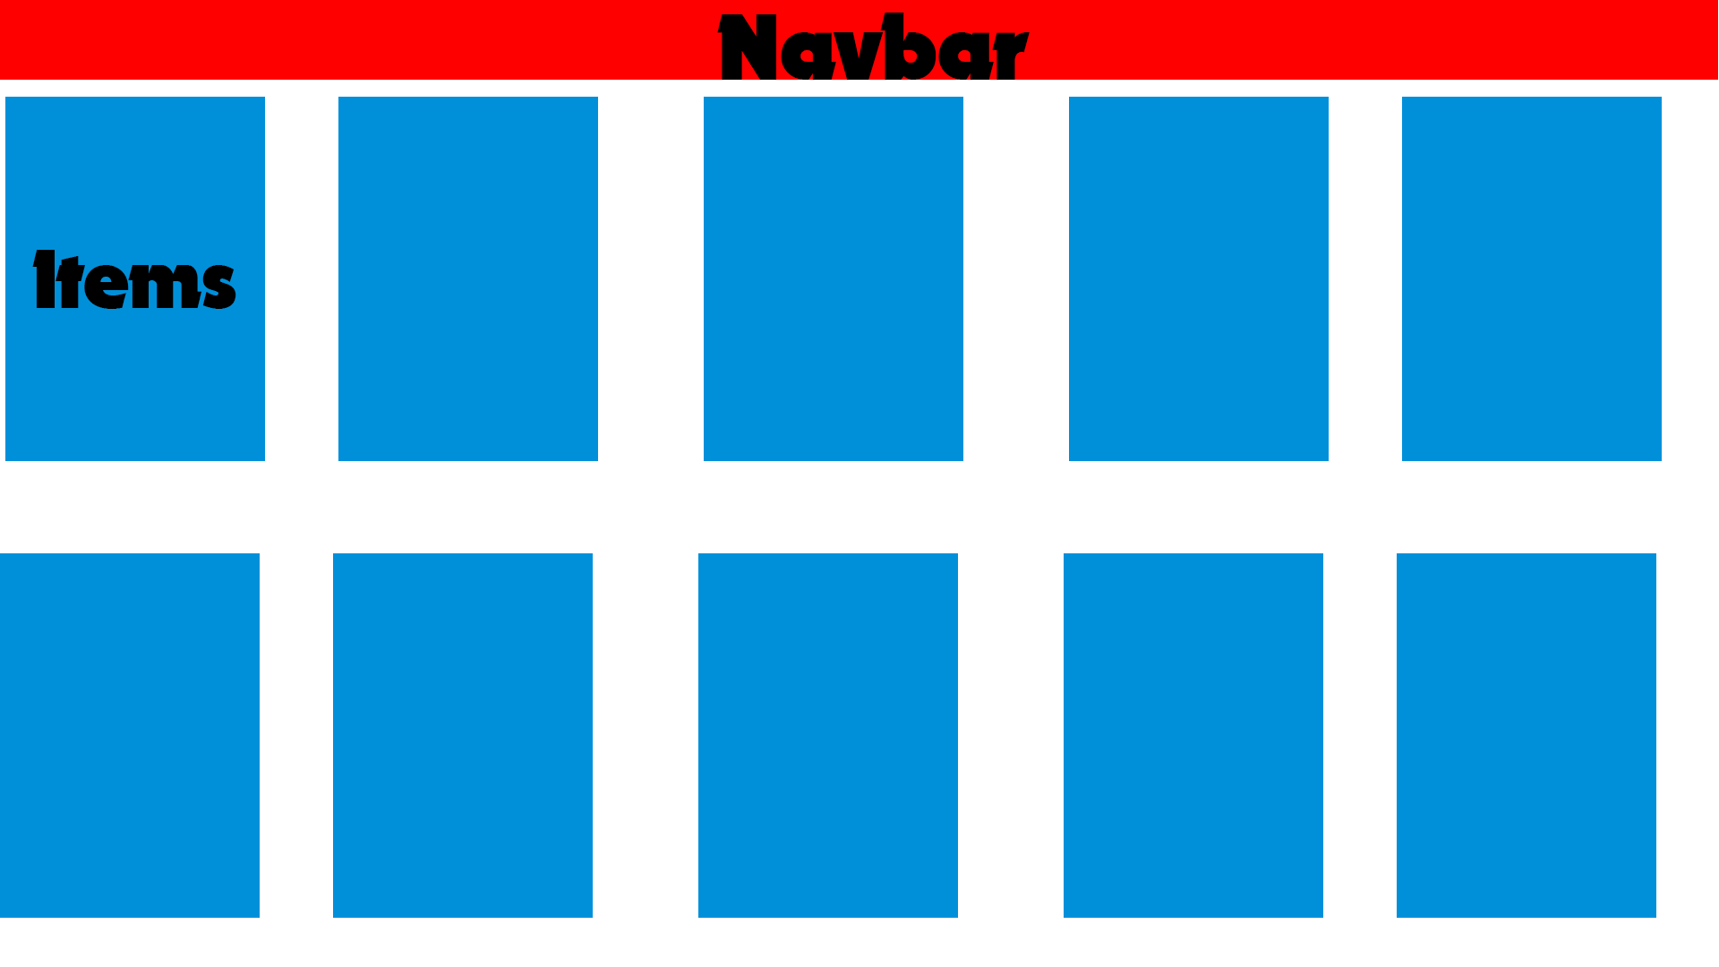

Outcome:

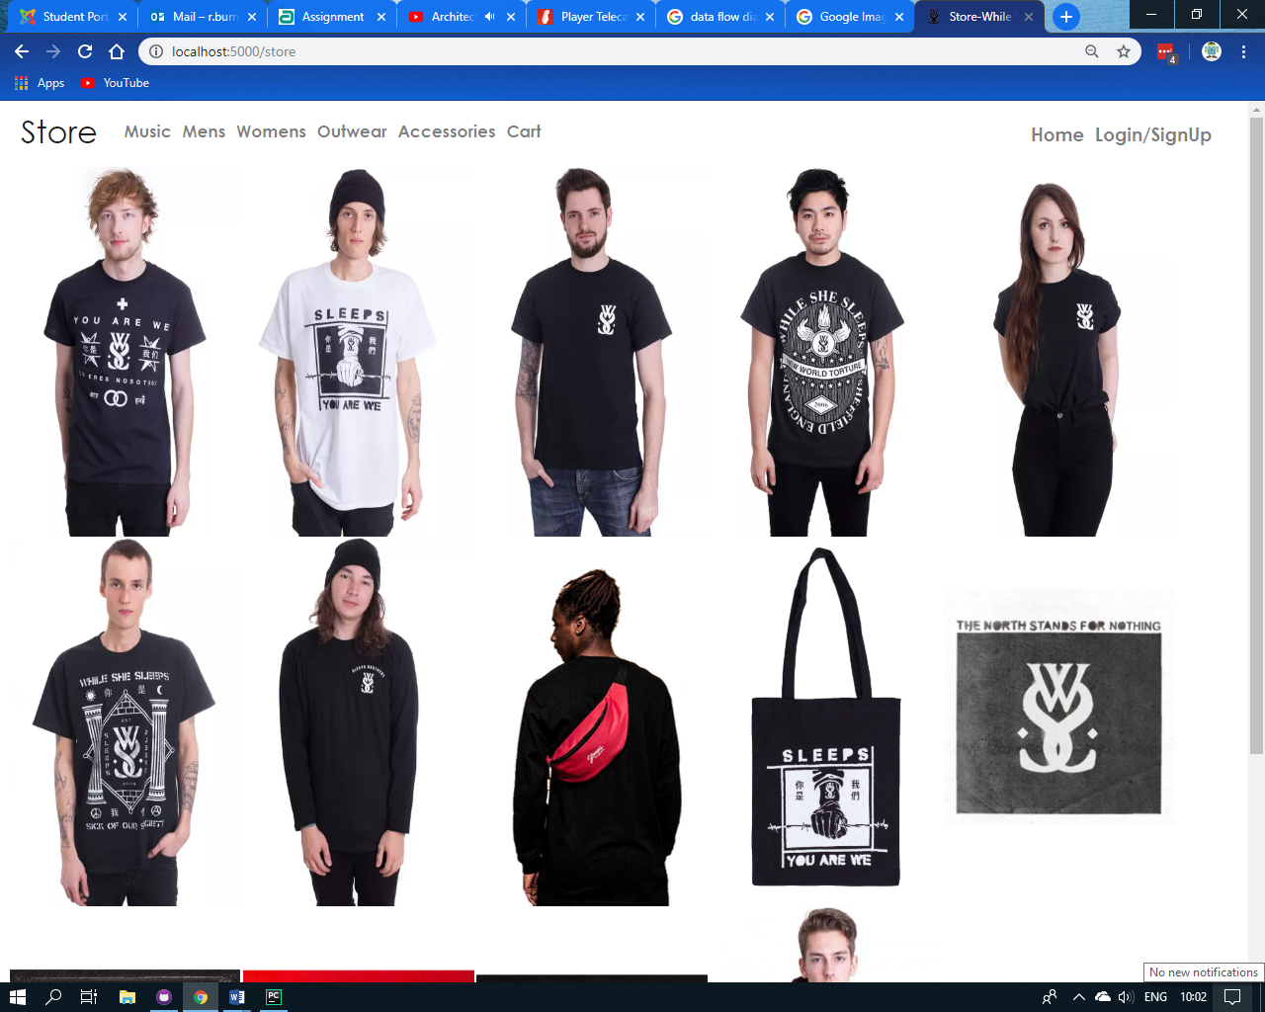

Admin Page

Design: 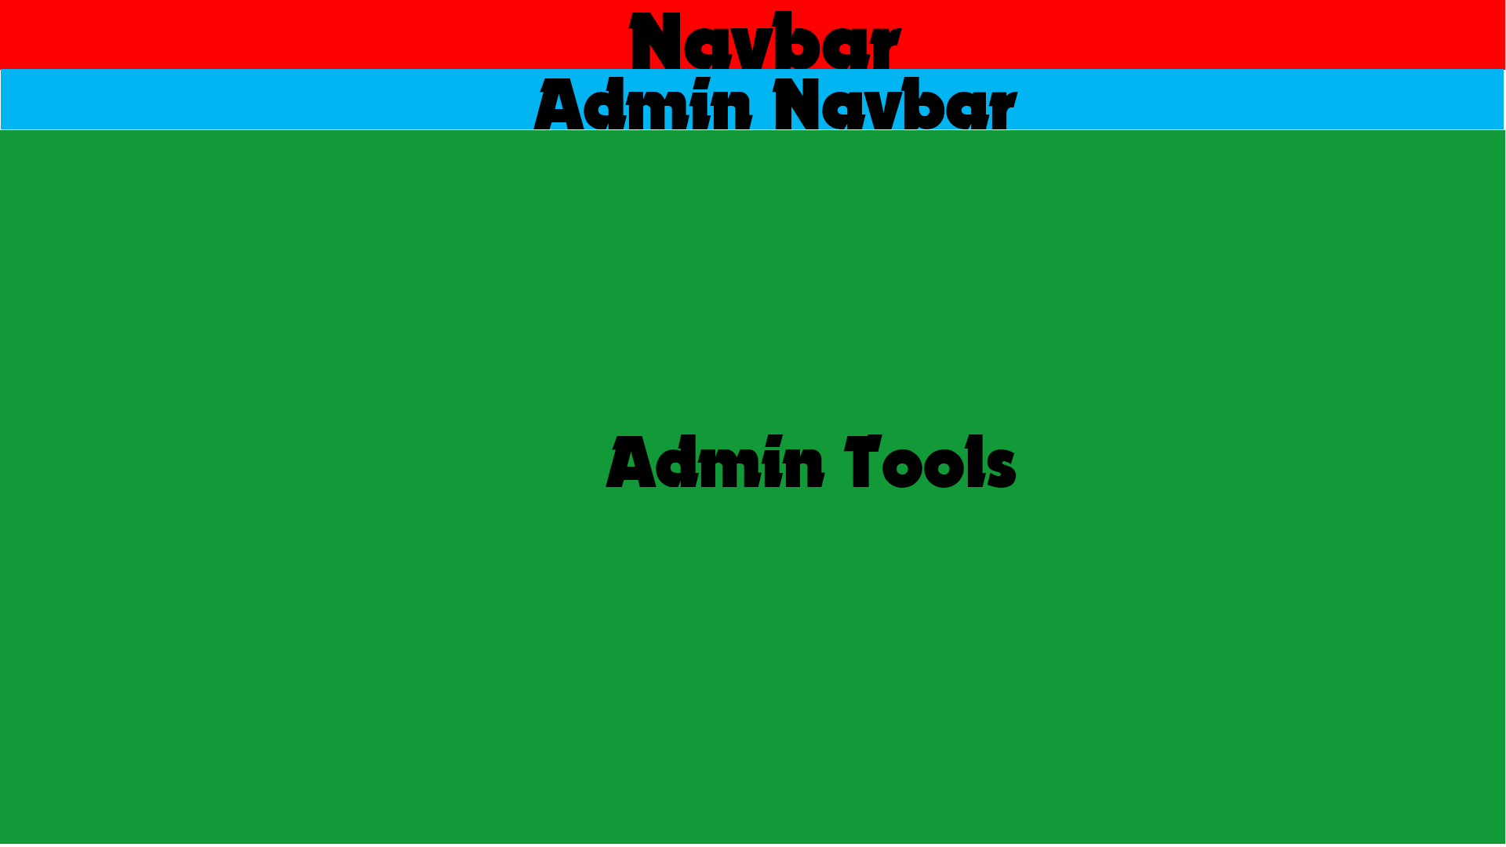

Outcome:

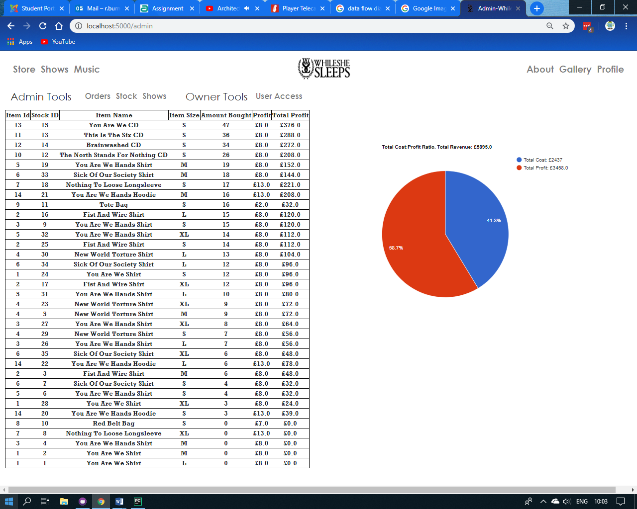

## Framework

* The website is built using python and Flask, this is because it has a straight forward layout meaning necessary files are neat and easy to read as there is not just random code all over the place. Also, python is capable of everything that I need, I do not need anything more complex for the tasks. Flask also complies with SQL very well and integrating databases into my website was easily achieved. Flask also allows for a dedicated layout page, which means my html files can be small and more concise as I only need the body in the file and edits in the head. The stylesheet I will be using is Bootstrap, this is because bootstrap is the most common stylesheet on the internet meaning it is very stable and will play nicely with all the most common browsers.

## Security and Validation

* All of the passwords are hashed when saved so the password text is not store anywhere in any database. This is so that even if the databases were hacked, passwords were not be leaked. Also the user’s credit card info is never stored and is deleted immediately after user, if this was going to be used in the real world, then I would implement PayPal as it is the most common, secure way of paying for things.
* All of the admin pages and owner pages are secured behind a user access level check. If no user is logged in, then the url will return a 404 error. If the user has an access level of 1, the url will return a 404 error. If the user has an access level of 2, then it will return the admin page and if the user has an access level of 3 it will return the admin page along with the owner tools.

## Flow Charts

Index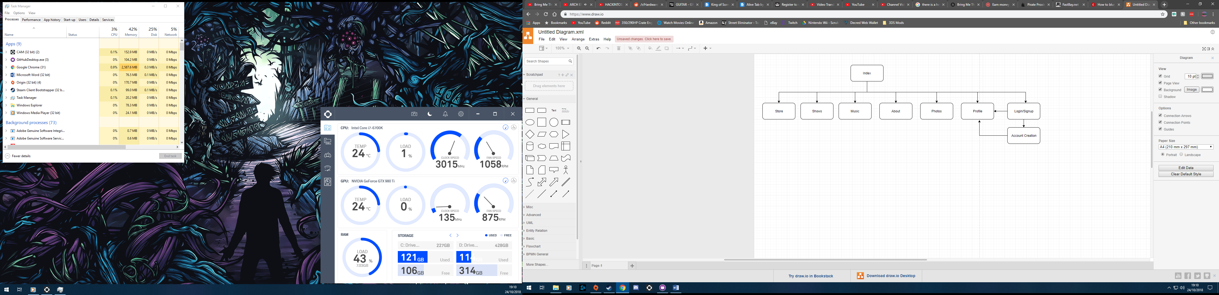

Store

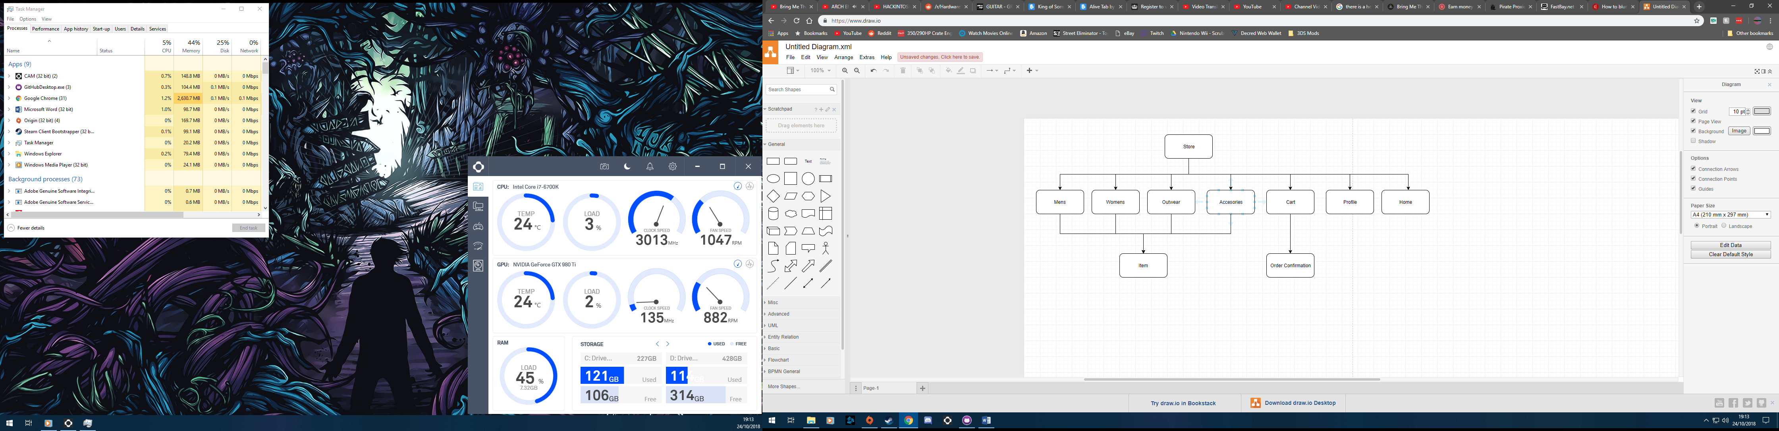

Profile

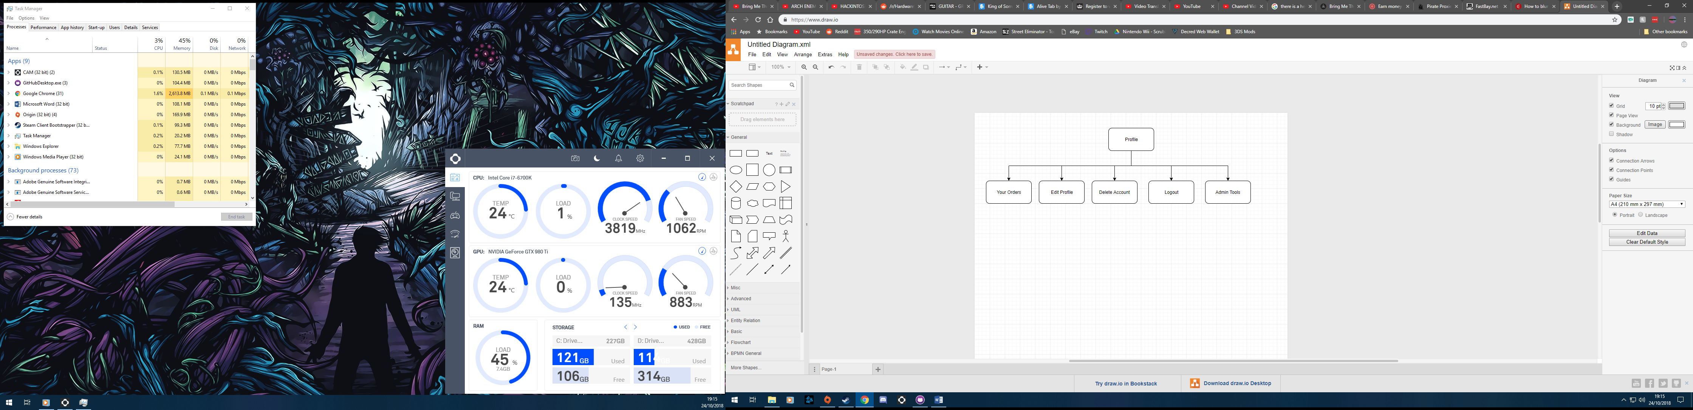

Admin Tools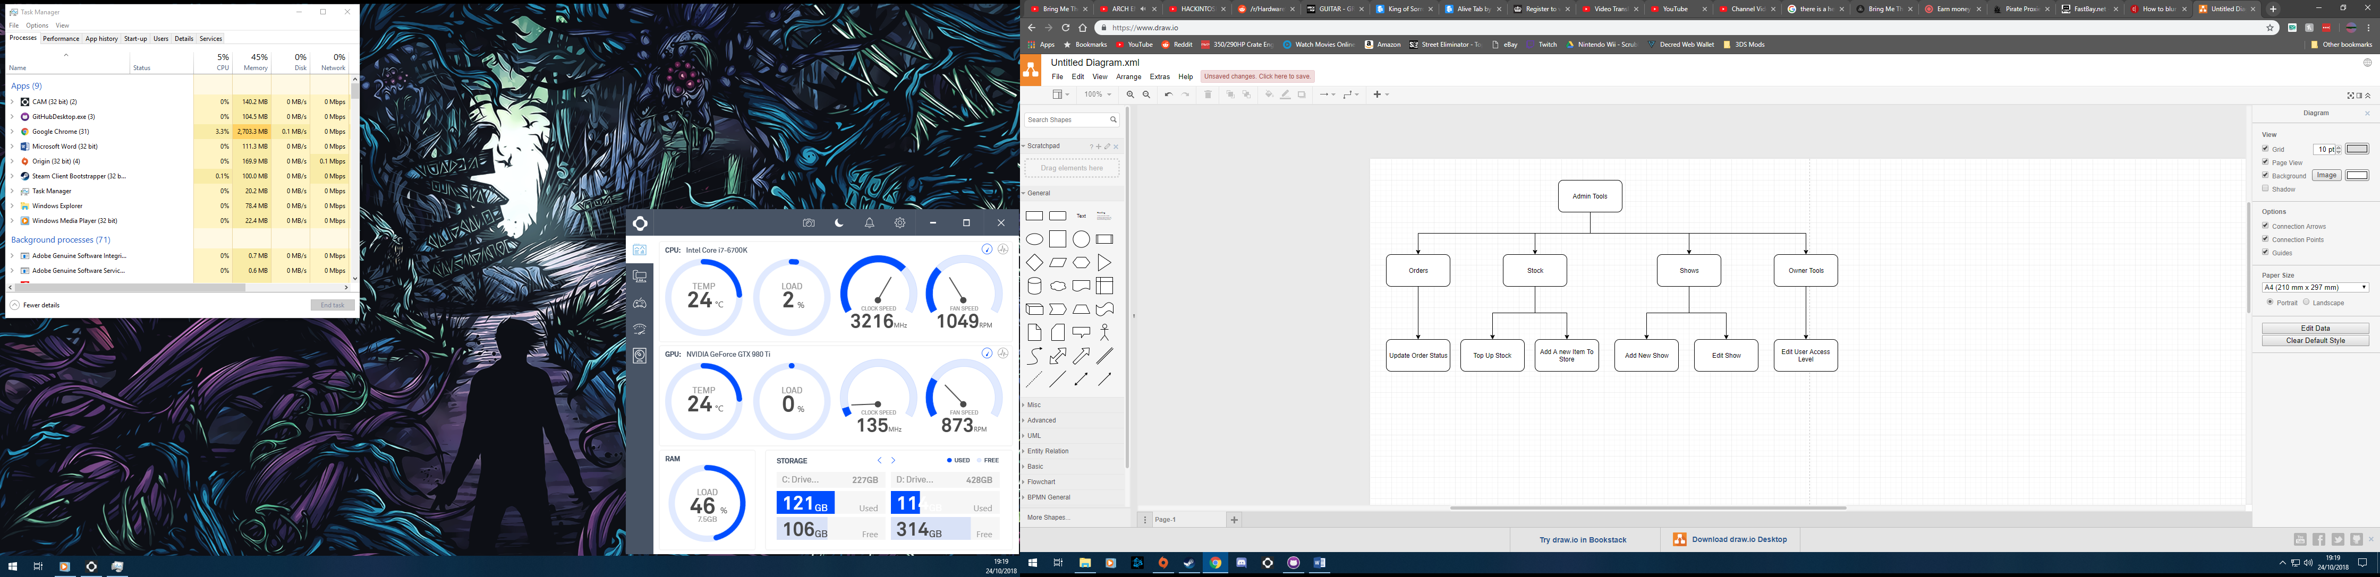

## Entity Relationship Diagram

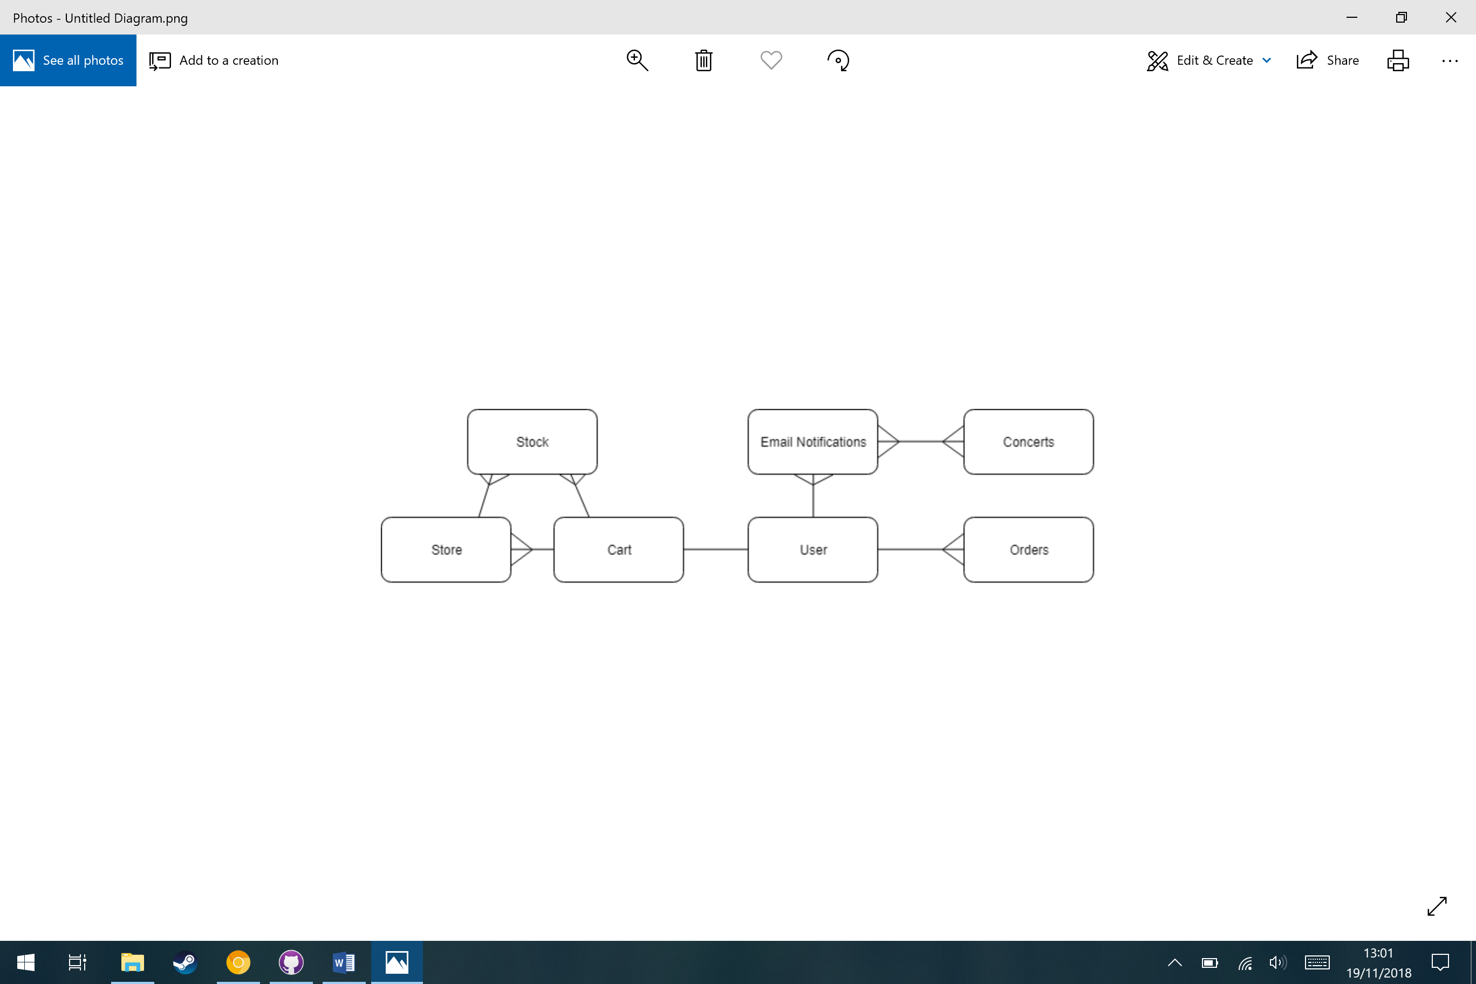

## 

## Data Dictionary

|  |  |  |  |  |  |
| --- | --- | --- | --- | --- | --- |
| Field Name | Data Type | Data Format | Field Size | Description | Example |
| User ID | Integer | Number |  | The unique identifier for each user | 21 |
| Username | String |  | 64 | The unique name used to log into an account | Kevin |
| Email | String | (String)@(String).(String) | 120 | The unique email address that is used for notifications for each user. | Kevinrules@  gmail.com |
| Password Hash | String |  | 128 | The hashed version of the password for the user. This makes I secure as it’s the only version stored | pbkdf2:sh  a256:50000  $HnTMT0Sw  $bfa97d334  c11 |
| Address 1 | String |  | 40 | The first line of a user’s address | 13 Royal Road |
| Address 2 | String |  | 40 | The second line of a user’s address | Norwich |
| Postcode | String |  | 9 | The postcode of the user | YR5 7LD |
| Town/City | String |  | 40 | The town or City that the user lives in | Manchester |
| Access Level | Integer | N | 1 | This number determines the access that the user has to the website | 2 |
| Name | String |  | 40 | The users full name | Kevin Smith |
| Card no. | Integer | NNNN | 4 | The last 4 digits of the user’s card | 1254 |
| Store ID | Integer | Number |  | The unique identifier of each item in the store | 45 |
| Name | String |  | 40 | The name of an item in the store | You Are We T Shirt |
| Image | String |  | 40 | A link to the location of the image of the item | Youareweshirt  Front.jpeg |
| Back Image | String |  | 40 | ^ | Youareweshirt  Back.jpeg |
| Category | String |  | 40 | The category of the item in the store | Mens |
| Price | Float | NN.NN |  | The price of an item | 15.00 |
| Sale Percentage | Integer | NN |  | The percentage of sale on an item | 00 |
| Cost | Float | NN.NN |  | The cost to produce the item | 7.00 |
| Stock ID | Integer | Number |  | The unique identifier if the item stock | 4 |
| Size | String |  | 1 | The size of the item | L |
| Colour | String |  | 40 | The colour of the item | Black |
| Amount Bought | Integer | Number |  | The total amount of the item has been bought | 45 |
| Show ID | Integer | Number |  | The unique identifier for each show | 45 |
| Location | String |  | 40 | The location of the show | Manchester |
| Venue | String |  | 40 | The venue of where the show takes place | Club 0 |
| Day | Integer | NN | 2 | The day of the show | 22 |
| 0 | Integer | NN | 2 | The month of the show | 11 |
| Year | Integer | NNNN | 4 | The year of the show | 2019 |
| Show Notification ID | Integer | Number |  | The unique identifier of the show notification to a user | 12 |
| Location | String |  | 40 | The location that the user wants notifications for. | Nottingham |
| Order ID | Integer | Number |  | The unique ID for each order | 15 |
| Item Quantity | Integer | Number |  | The amount of a single item has been | 5 |
| Order Status | String |  | 40 | The status of each order at the exact moment | Delivered |
| Date | String | NN-NN-NNNN |  | The date the order was placed | 11-08-2018 |
| Price | Float | NN.NN |  | The total price of the order | 15.00 |
| Cart ID | Integer | Number |  | The unique ID of each user’s cart | 6 |
| Size | String |  | 1 | The size of each item in a user’s cart | M |
| Quantity | String | Number | 40 | The amount of each item in a user’s cart | 1 |
| Price | Float | NN.NN |  | The price of each item in the user’s cart | 22.00 |

## Data Flow

# 

# Testing

## Test Strategy

My website and store will need to be tested toughly before it can be released to the public. This is to make sure that all users can a pleasant and easy explirence on the site. When testing, I will be looking for errors within my code and also the layout of the website. When found, the errors will be corrected. In my testing I will be checking for major and minor errors, but also the user experience. I will be using the following method for my testing:

I will start at the homepage as this is the first page that anyone will see if they enter the site. I will check that each of the links work on this page and that the page still flush on the user’s screen.

From here, I will go to the login/register page and show that a user can be created and then the user can login and logout easily. I will also show that a user cannot be logged in if the password is incorrect and that another account cannot be created with the same username or email. Registering an account can be used to save the user’s address, orders and set up email notifications of shows in their area. So the page must be easily read and edited as it is the most used part of the website. When logged in, the user can access their profile from the same place to login link was. From here the user can see all the data stored of them, see their orders. Edit their account, delete their account and log out. I will show that all of these functions work and that there are measures to stop accidental edits or deletion, by being password protected. Also, if the logged in user is of admin or owner status, then the admin tools page link will show up in the profile. Only a user will an access level of 2 or 3 can enter this page. I will prove that a non-admin cannot enter this or the owner page by trying to access it with a user with access level of 1, 2 and 3 and show what the differences are. On the admin section, an admin can see all the stock with the profit that that each item brings in, with the total profit of the website. They can view all shows, add a new show or edit an existing one. They can add stock to one item or add an entirely new item to store and finally they can view all the orders from all users and edit the status of them (dispatched and delivered). I will show all this working on test data that will be created through the testing of the other parts of the website such as ordering items from the store. In the user is of access level 3, when they enter the admin tools page, they will also see the owner tools sections, and here they can change the access level of each user to 1, 2 or 3. After this I will show how the shows that have already passed will be automatically deleted from the database. Even if the date is edited. And, how the user can set up email notifications for a specific location and if there is a show there, they will get an email.

Next, I will show the store and all the items in it. How each item has their own individual page, where it shows pictures, price and how much stock each size has. From here you can select what size and the quantity of item that the user wants to put into their cart. Then I will access my cart by clicking the cart icon on the navigation bar. This page shows all of the items in the specific user’s cart, the amount of each item and the total price of all the items. I will show how items can be removed or quantity lowered easily, by pressing the “remove” button. From here I will continue onto the confirming order page. The next page is the address confirmation, where the address entered on the profile will be brought forward but if it is not correct then there is a link to change it. After this, the next page is the payment page, where I will put some a card number, date and CVV, this is test data and money will not be taken. After this page is the order confirmation page, this is where the users’ cart, address and card will be shown so the user can make sure that it is correct. When the order is placed, I will show how the order has been added to the “Your Orders” page on the profile and how an email has been sent to the specific email that the user set in their account creation. After this, I will show how different users can only see their own orders and cart. This is to make sure that users do not get other users orders on their page and don’t get confused by it.

After this, I will logout of this account and login to an owner account. From here, I will show that when you are an admin or an owner, there is now a new link to the admin tools in the profile. I will then go to the admin page but straight after logout of my account and back into the test account. I will then show that even if a user knows the url, if they do not have the access level, then they cannot enter the admin or owner page and it will just return a 404 error. Now I will log back into the admin account and back into the “admin tools” page. On the main admin page, it shows the entire stock and how much profit each item makes. There is also a pie chart that shows the website’s costs and profits. There is also an additional navbar for the admin tools section, and if the user has an access level of 3, will also get the owner tools here. I will then show this difference by showing that the logged in account (“Richard”) has an access level of 3, and then I will log into an admin account and when I go onto the admin tools, the “owner tools” section will not be there. In the “Stock” section of the admin tools, it shows the user all the stock and the information on the items, for example the amount bought and price. From this page, I will show that an admin can top up the stock of a specific item and add a new item to the store entirely. After this is will show the orders page, this page shows all of the orders of all of the users. Its also shows the status of their order, however if the status of the order is delivered, the order is not shown in the table. Also, from this page, I will show that an admin can change the status of an order, when it is needed, this would be when the order has been dispatched and confirmed as delivered. When an order status is changed, the users who created the order will receive an email of the status change pf their order, I will show this happening for both “dispatched” and “delivered”. The final part of the admin page is the shows tools. This is where the admin can see all the upcoming shows. They can also create and edit the show easily. I will show the creation and editing of a show and in doing so I will created one that has a date that already past, this is because when someone enter the “shows” page, the website works out the current date and compares it to the date of the show and if the show has a date that has already been, it will delete that show from the database, so it will not be displayed.

Next, I will show the owner tools page, here the owner (someone of access level of 3), can see all the users on the database, along with their full name and their email. Here an owner can change the access level of a specific user to either 1 (regular user), 2 (admin) or 3 (owner). And I can show how changing this leads users to be able to access the admin and owner tools.

I will show this by logging back out of the owner account and back into the test account. Now on the profile page, there will be the admin tools button. But when I go into it, the owner tools section is missing, this is because to access owner tools an access level of 3 is needed, which this account doesn’t have.

After I have shown this, I will show how an order status can be changed by selecting the order id and changing the status to “Dispatched”. When this happens, the website also sends an email to the user telling them that their order has been dispatched. I will show this happening by using a test account on Gmail. The same also applies to when an order is changed to “Delivered”, however this order now disappears from the orders table, this is because the “delivered” orders are all filtered out, so it does not clutter up the page. Next, I will show the stock page, this page shows all the stock and necessary information on it. From this page and admin is able to add stock to an existing item or create a new item entirely. I will show both working.

Following this, I will show how the show email notifications work. So, a user will go to the “shows” page and then from here press the link to “Set Up Email Notification”. From here the user types in the location for which they would like to receive emails for. The email used is pulled directly from the User Database. Now when I go back into the admin tools page and the shows section when I created a show or edit an existing one, It scan the email notifications database and if there is a match, it will send and email to the user, with the location in the email, in case they have set up multiple email notifications.

Finally, I will show how other others are not able to access any data on any other user. I will show this by showing that a user can only ever access their own profile, even if they type in other users’ url. Also, I will show how the different users’ cart stay different, so peoples saved items don’t cross into other users’ cart. Also, during this I will show that a user’s cart is saved so even if they don’t enter the site for a year, along as the item still exists, it will still be in their cart.

## Testing video

<https://youtu.be/DLxIps2yyZY>

## Test Table

|  |  |  |  |  |  |  |
| --- | --- | --- | --- | --- | --- | --- |
| Test No. | Purpose of the test | Test Data | Expected Outcome | Actual Outcome | Changes Needed | Video Timestamp |
| 1 | Create account. Check if for requirements work. | U: test  E: wsstestdat  P: Test | Account Created. And form works | Account Created and form works | None | 01:04 |
| 2 | Login | U: test  P: test | Logs into account | Logs into account | None | 01:10 |
| 3 | Profile works and all link in profile | None | All open | All open | None | 01:17 |
| 4 | Access profile without being logged in | /profile/test | Login error. Redirects to login page | Login error. Redirects to login page | None | 01:49 |
| 5 | Access test profile while logged in to another account | /profile/test | Loads profile for logged in user | Loads profile for logged in user | None | 02:02 |
| 6 | Incorrect Username | U: test1 | Will not login | Will not login | None | 02:14 |
| 7 | Incorrect Password | P:test1 | Will not login | Will not login | None | 02:17 |
| 8 | Edit Profile | Name: Rich | Changes made to database | “CSRF Token Missing” Error | Find/create token | 02:39 |
| 9 | Showing all links on index navbar work | None | All pages open | All pages open | None | 02:50 |
| 10 | Show all links work in the store | None | All pages open | All pages open | None | 03:17 |
| 11 | Each item has a specific page | None | Item Page Open | Item Page opens | None | 03:31 |
| 12 | Add item to cart | M 3 | Items adds to cart | Items adds to cart | None | 03:36 |
| 13 | Remove 1 items from cart | None | Quantity goes to 2 | Quantity goes to 2 | None | 03:42 |
| 14 | Add second item to cart | XL 1 | Adds item to cart | Adds item to cart | None | 03:49 |
| 15 | Remove item from cart | None | Removes item | Removes item | None | 05:54 |
| 16 | Checkout pulls address from profile | None | Address is present | Address is present | None | 04:02 |
| 17 | Card form can only take correct amount of numbers | 17 characters card number | Doesn’t continue card must be 16 characters | Doesn’t continue card must be 16 characters | None | 04:31 |
| 18 | Confirmation shows address, cart and last 4 digits of card | None | Address, cart and card number is present | Address, cart and card number is present | None | 04:35 |
| 19 | Order placed | None | Order is placed | Order is placed | None | 04:54 |
| 20 | Email is sent | None | Email is present | Email is present | None | 05:06 |
| 21 | Order is in “Your Orders” | None | Order is present | Order is Present | None | 05:22 |
| 22 | Admin tools pages open and google charts work | None | Pages open and google charts work | Pages open and google chart work | None | 05:59 |
| 23 | Update Order Status | 14 “Dispatched” | Order updates | Order Updates | None | 07:20 |
| 24 | Email is sent to user | None | Email is received | Email is received | None | 07:27 |
| 25 | Update order status | 14 “Delivered” | Order updates and disappears from table” | Order updates and disappears from table” | None | 07:35 |
| 26 | Change Access Level | Test 2 [password] | Access level changes | Access level changes | None | 08:16 |
| 27 | Show admin tools shows up in test profile | None | Admin tools link is present | Admin tools link is present | None | 08:37 |
| 28 | Show that owner tool sis not here for access level 2 | None | Owner tools is not present | Owner tools is not present | None | 08:37 |
| 29 | Set up email notifications | London | Set up works | Set up works | None | 08:46 |
| 30 | Add a show | London 18 11 2021 gfvsfg | Show is added | Show is added | None | 09:15 |
| 31 | Email is sent out | None | Email is received | Email is not received | Check the email is correct and is sent to the correct person as It works on my other account | 09:25 |
| 32 | Show is in Shows page | None | New show is present | New show is present | None | 09:31 |
| 33 | Show that if a show is in the past, it will be deleted | Afa 1 1 2018 fvuhsf | Show is in table but then not in shows page because it is deleted | Show is in table but then not in shows page because it is deleted | None | 09:48 |
| 34 | Try and get into admin tools when not logged in | /admin | Returns 404 error | Returns 404 error “page not found” | None | 10:30 |
| 35 | Try and get into admin tools as logged in user with access level of 1 | /admin | Returns 404 error | Returns 404 error | None | 11:30 |
| 36 | Orders are different between account | 2 accounts | Order pages are different | Order pages are different | None | 11:57 |
| 37 | Cart pages are different between users | 2 accounts | Carts are different between users | Carts are different between users | None | 12:17 |

## User Feedback

**How easy was the website to navigate?**

It was very easy to navigate because of the navigation bar, this made it easy to know where I was on the website and be able to move to different pages easily. Also, the second navigation bar on the admin tools section of the website made it easy and fluent to move around the admin tools and onto other parts of the website.

**How does the website meet the objectives?**

The website meets all the core objectives, such as emailing the user when there is an order update or when a show is in an area where they requested email notifications. The store section of the website works flawlessly, even if there are not many items in the shop, it is easy to add and remove items from the cart and they is no delay in the cart updating. All the User specific objectives were met and work well, for example the editing/deletion of accounts work instantly. The admins of the website are able to update orders, view stock statistic and add new shows/stock/new items to the store, however there is no option for an admin to put an item on sale, so this objective has failed. All the validation for the text fields works well, such as email, password, card number etc.

**How easy was it to order an item from the store?**

It was very straightforward, I could add the items I want in the sizes that I wanted to cart easily and then if I changed my mind, I could remove them easily. The payment and delivery pages were very easy to navigate and not time consuming as the delivery address was pulled from my account and I didn’t need to change, but if I needed to the option was there. The final page was an order confirmation page where I was shown all of data necessary to complete my purchase: my cart, the total cost, my delivery address and payment method. Once my order was complete, I could track it easily by going to the “My Orders” section of my profile which was updated instantly with the status of all my current orders.

**Do you have any criticisms of the website?**

A lot of the pages seem very blank as there is not a lot of contend and the backgrounds are all plain white. The postage set for an order is set at a constant and this is unrealistic as the price to post 1 shirt to posting 20 would be vastly different and the postage that the user must pay is not representative of it.

**What improvements would you recommend?**

Improvements that I would recommend would be to add a variable postage price depending on the number of items that the user is purchasing, to add more content to some of the pages because they make the website feel unfinished and empty. And finally, to add the ability for admins to be able to change the sale value of a particular item in the store.

## Analysis of User Feedback

All of the feedback that I have received have been mostly positive which gives me the confidence to say that I have completed what I set out to do, in creating a webstore and that I have completed the majority, if not all of the objectives required to make this website work. The fact that the user did not have any trouble with moving around the website and getting to where to they wanted to be, reassured me that I have created and nice, usable user interface that anyone is able to use comfortably. Although, it would have been nice to allow the user to customise their own experience on the website, such as add a dark mode option.

If I had more time on this project or the option to do it again, I would do most things similar to the way I have done now, as it is functional, and errors are easy to find and diagnose with the way I have set up my emails, and database. More statistics could be added for admins to see where all of the traffic on the website was and which pages were getting the most hits. A forum type [art of the website would have been a cool addition to the website to help keep fans coming back increasing the likelihood of sales and the more could be made of adverts, making the website more profitable overall, however this would have taken a long time to make functional and it would have meant other crucial parts of the website would have been rushed. I would also add more items to the store and more pictures to the website to fill up the space for but as I was on a time limit, these additions did not make any sense to spend time on as they do not add any additional complexity to the website.

# Evaluation

|  |  |  |  |
| --- | --- | --- | --- |
| Objective | Met | Comment | Test Reference |
| Have a functioning profile system | Yes | Each user has a profile which shows the data stored on them and gives them a link to their orders. Each user is also able to edit or delete their account from here | 3 |
| Be able to update the profile by the user | No | There is a CSRF Token Missing” error which is messing with the form. However, this has been met before | 8 |
| Have a store that can be used by the user to buy merchandise | Yes |  | 9-20 |
| Have the store pull the address from the user’s profile but ask whether it is correct. | Yes | The user’s address is displayed and if it is not correct, there is a link that allows the user to change it. | 16 |
| Have a most popular page on the store that is automatically updated with the items that have been bought the most | No | This could be implemented as the algorithm is in use on the admin index page. However, it is not used as there is not enough stock to warrant it’s use. | 10 |
| Have an easily updatable shows page, that’s takes of a show when it is in the past | Yes | Whenever, someone enters the shows page, the website gets the current date and compares it to date of the show and if the show is before then it is deleted from the database | 33 |
| Have the shows page be updated by an admin | Yes | A show can be created or edited easily by an admin in the admin tools section of their profile | 30 |
| Have tweets from their official twitter integrated into the home page | Yes | The band official twitter feed is on the right band side of the homepage | 0 (first second in the video is the homepage, and this page is shown multiple times throughout the video) |
| Be able to put items from different categories into the cart | Yes | This can be done very easily and was never a problem to begin with | 14 |
| Have a clean that is easy to understand so people can easily navigate around the website | Yes | There are navigation bars on every page that has the necessary links the move around dedicated area | The whole video shows this |
| Have an admin page that can be used to manage the shows page, the stock and orders | Yes | In the admin tools, an admin can update all of these with new shows, edit shows, top up stock, add a new item to the store and update orders | 22 |
| Remember the cart for a specific user when the user closes the website or logs out | Yes | The cart is saved in a database so unless the user removes an item, it will stay there | 37 |
| Let the user delete their account | Yes | They just have to confirm their password and click submit and their account is deleted from the database | Is not shown in the video but is easy done by a db.session.remove(user) |
| Have the website show all the necessary information on the band | Yes | There is an about page which houses all of this information | 9 |
| Have a page to view previous order with the amount spent and items bought | Yes | This is the “your orders” page in the profile section. This displays all previous order, the cost and the status amongst other things | 21 |
| Have a page that can show the status of the ongoing orders | Yes | This is also the “Your Orders” page in the profile section | 21 |
| Have different level of access for different users | Yes | Each user has an access level, 1: regular user, 2: admin and 3: owner | 26 |
| Have a page where an owner can change the permissions of the users | Yes | This is the owner part of the admin tools. Where an owner can select a user and then change their access level, but they also have to enter their password | 26 |
| Let an admin add shows or edit shows | Yes | This is done in the admin tool section and works for both editing and creating shows | 30 |
| Let an admin add a new item to the store or add stock to an existing item | Yes | An admin can easily create a new item using a form or add stock to existing item with a drop-down selector for the item and then they enter an amount to add to it | This is not shown in the video, but the process is shown multiple times, it is just adding something to a database or increasing a number in a database |
| Allow an admin to put an item on sale | No | I didn’t include the sale to work into the price, so this would have no purpose | N/A |
| Allow admins to see all the orders that aren’t delivered and change their status | Yes | An admin can see all the orders and be selecting an order using a drop-down can change the status of it | 23 |
| Have email notifications for shows that are coming to a specific area | Yes | This worked on my person al account but not on my test data | 31 |

# Technical Solution

## Backend Files

Cousework.py

1. **from** app **import** app, db
2. **from** app.models **import** User, Concerts, Store, cart, stock
3. **from** flask_wtf **import** CSRFProtect

6. @app.shell_context_processor
7. **def** make_shell_context():
8. **return** {
9. 'db': db,
10. 'User': User,
11. 'store': Store,
12. 'Concert': Concerts,
13. "Stock": stock,
14. "Cart": cart,
15. }
17. csrf = CSRFProtect()
19. **if** __name__ == '__main__':
20. app.run(host="0.0.0.0")
21. # app.run(host="80.80.80.80")
22. # app.run()

Config.py

1. **import** os
2. **import** smtplib
3. basedir = os.path.abspath(os.path.dirname(__file__))

6. **class** Config:
7. SECRET_KEY = os.environ.get("SECRET_KEY") **or** "you_will_never_guess"
8. SQLALCHEMY_DATABASE_URI = os.environ.get("DATABASE_URL") **or** "sqlite:///" + os.path.join(basedir, "app.db")
9. SQLALCHEMY_TRACK_MODIFICATIONS = False
11. server = smtplib.SMTP(host="smtp.gmail.com", port=587)
12. server.starttls()
13. server.login("whileshesleeps.store.tester@gmail.com", "whileshesleeps")

app/init.py

1. **from** flask **import** Flask
2. **from** flask_sqlalchemy **import** SQLAlchemy
3. **from** flask_migrate **import** Migrate
4. **from** config **import** Config
5. **from** flask_login **import** LoginManager
7. app = Flask(__name__)
8. app.config.from_object(Config)
9. db = SQLAlchemy(app)
10. migrate = Migrate(app, db)
11. login = LoginManager(app)
12. login.login_view = "login"
14. **from** app **import** routes, models, errors

app/errors.py

1. **from** flask **import** render_template
2. **from** app **import** app, db

5. @app.errorhandler(404)
6. **def** not_found_error(error):
7. **return** render_template("error_pages/404.html"), 404
9. #  This is where an error page is called when an error is given out

app/forms.py

1. **from** wtforms **import** StringField, PasswordField, BooleanField, SubmitField, SelectField
2. **from** flask_wtf **import** FlaskForm
3. **from** wtforms.validators **import** DataRequired, ValidationError, Email, EqualTo, Length
4. **from** app.models **import** orders, User, stock, Concerts, Store

7. **class** LoginForm(FlaskForm):
8. username = StringField("Username", validators=[DataRequired()])
9. password = PasswordField("Password", validators=[DataRequired()])
10. remember_me = BooleanField("Remember Me")
11. submit = SubmitField("Sign In")

14. **class** RegisterForm(FlaskForm):
15. username = StringField("Username*", validators=[DataRequired()])
16. email = StringField("Email*", validators=[DataRequired(), Email()])
17. password = PasswordField("Password*", validators=[DataRequired()])
18. password2 = PasswordField("Repeat Password*", validators=[DataRequired(), EqualTo("password")])
19. submit = SubmitField("Register")
20. name = StringField("Name")
21. address1 = StringField("Address 1")
22. address2 = StringField("Address 2")
23. towncity = StringField("Town/City")
24. postcode = StringField("Postcode")
26. **def** validate_username(self, username):
27. user = User.query.filter_by(username=username.data).first()
28. **if** user **is** **not** None:
29. **raise** ValidationError("Please use a different username.")
31. **def** validate_email(self, email):
32. user = User.query.filter_by(email=email.data).first()
33. **if** user **is** **not** None:
34. **raise** ValidationError("Please use a different email address.")

37. **class** EditForm(FlaskForm):
38. email = StringField("Email")
39. address1 = StringField("Address 1")
40. address2 = StringField("Address 2")
41. towncity = StringField("Town/City")
42. postcode = StringField("Postcode")
43. submit = SubmitField("Submit Changes")
44. password = PasswordField("Password")
45. password2 = PasswordField("Repeat Password", validators=[EqualTo("password")])
46. og_password = PasswordField("Current Password", validators=[DataRequired()])
47. name = StringField("Name")

50. **def** validate_username(self, username):
51. user = User.query.filter_by(username=username.data).first()
52. **if** user **is** **not** None:
53. **raise** ValidationError("Please use a different username.")

56. **class** add_shows(FlaskForm):
57. location = StringField("Location")
58. # thedate = StringField("Date")
59. venue = StringField("Venue")
60. submit = SubmitField("Submit")
61. day = SelectField(
62. choices=[("01", "01"), ("02", "02"), ("03", "03"), ("04", "04"), ("05", "05"), ("06", "06"), ("07", "07"), ("08", "08"),
63. ("09", "09"), ("10", "10"), ("11", "11"), ("12", "12"), ("13", "13"), ("14", "14"), ("15", "15"),
64. ("16", "16"), ("17", "17"), ("18", "18"), ("19", "19"), ("20", "20"), ("21", "21"), ("22", "22"),
65. ("23", "23"), ("24", "24"), ("25", "25"), ("26", "26"), ("27", "27"), ("28", "28"), ("29", "29"),
66. ("30", "30"), ("31", "31")])
67. month = SelectField(
68. choices=[("01", "01"), ("02", "02"), ("03", "03"), ("04", "04"), ("05", "05"), ("06", "06"), ("07", "07"), ("08", "08"),
69. ("09", "09"), ("10", "10"), ("11", "11"), ("12", "12")])
70. year = SelectField(choices=[("2018", "2018"), ("2019", "2019"), ("2020", "2020"), ("2021", "2021")])

73. **class** edit_shows(FlaskForm):
74. location = StringField("Location")
75. venue = StringField("Venue")
76. submit = SubmitField("Submit")
77. day = SelectField(
78. choices=[("01", "01"), ("02", "02"), ("03", "03"), ("04", "04"), ("05", "05"), ("06", "06"), ("07", "07"), ("08", "08"),
79. ("09", "09"), ("10", "10"), ("11", "11"), ("12", "12"), ("13", "13"), ("14", "14"), ("15", "15"),
80. ("16", "16"), ("17", "17"), ("18", "18"), ("19", "19"), ("20", "20"), ("21", "21"), ("22", "22"),
81. ("23", "23"), ("24", "24"), ("25", "25"), ("26", "26"), ("27", "27"), ("28", "28"), ("29", "29"),
82. ("30", "30"), ("31", "31")])
83. month = SelectField(
84. choices=[("01", "01"), ("02", "02"), ("03", "03"), ("04", "04"), ("05", "05"), ("06", "06"), ("07", "07"), ("08", "08"),
85. ("09", "09"), ("10", "10"), ("11", "11"), ("12", "12")])
86. year = SelectField(choices=[("2018", "2018"), ("2019", "2019"), ("2020", "2020"), ("2021", "2021")])
87. the_list = [(None, "Select Show ID")]
88. **for** i **in** Concerts.query.all():
89. the_list.append((str(i.id), str(i.id)))
90. show_id = SelectField(
91. choices=the_list
92. )

95. **class** edit_user_level(FlaskForm):
96. the_list = [(None, "Select User")]
97. **for** i **in** User.query.all():
98. the_list.append((str(i.username), str(i.username)))
99. username = SelectField(
100. choices=the_list
101. )
102. accesslevel = SelectField(
103. choices=[(None, "Select Access Level"), ("1", "1"), ("2", "2"), ("3", "3")]
104. )
105. password = PasswordField("Enter Your Password ", validators=[DataRequired()])
106. submit = SubmitField("Submit")

109. **class** add_to_cart(FlaskForm):
110. size = SelectField(choices=[("Select Size", "Select Size"), ("S", "S"), ("M", "M"), ("L","L"), ("XL", "XL")])
111. amount = SelectField(choices=[("1", "1"), ("2", "2"), ("3", "3"), ("4", "4"), ("5", "5"), ("6", "6"), ("7", "7"), ("8", "8"), ("9", "9")])
112. submit = SubmitField("Add To Cart")

115. **class** add_item_to_store(FlaskForm):
116. item_id = StringField("Item ID", validators=[DataRequired()])
117. name = StringField("Item Name", validators=[DataRequired()])
118. price = StringField("Price", validators=[DataRequired()])
119. sale = StringField("Sale % (If Applicable)")
120. image = StringField("Image Url (In Form images/folder/image)")
121. back_image = StringField("2nd Image Url")
122. size = StringField("Size", validators=[DataRequired()])
123. stock = StringField("Stock", validators=[DataRequired()])
124. colour = StringField("Colour", validators=[DataRequired()])
125. submit = SubmitField("Submit", validators=[DataRequired()])
126. catagory = SelectField(
127. choices=[(None, "Select"), ("Mens", "Mens"), ("Womens", "Womens"), ("Outwear", "Outwear"), ("Accessories", "Accessories"), ("Music", "Music")]
128. )
130. **def** validate_id(self, item_id):
131. **for** i **in** Store.query.all():
132. **if** i.id == item_id.data:
133. **raise** ValidationError("Please use a different Item ID.")

136. **class** checkout(FlaskForm):
137. submit = SubmitField("Checkout")
139. **class** pay_money(FlaskForm):
140. card = StringField("Card Number", validators=[DataRequired(), Length(min=16, max=16)])
141. date = StringField("Expiry Date", validators=[DataRequired(), Length(min=5, max=5)])
142. cvv = StringField("CVV", validators=[DataRequired(), Length(min=3, max=16)])
143. submit = SubmitField("Next")
145. **class** topup_form(FlaskForm):
146. the_list = [(None, "Select Item ID")]
147. **for** i **in** stock.query.all():
148. the_list.append((str(i.id), str(i.id)))
149. item = SelectField(
150. choices=the_list
151. )
152. amount = StringField("Amount Of Stock Added")
153. submit = SubmitField("Submit")
155. **class** pay_form(FlaskForm):
156. card = StringField("Card No.")
157. date = StringField("Expiry Date")
158. cvv = StringField("CVV")
159. submit = SubmitField("Place Order")
161. **class** update_orders_form(FlaskForm):
162. the_list = [(None, "Select Order ID")]
163. **for** i **in** orders.query.all():
164. the_list.append((str(i.order_id), str(i.order_id)))
165. select = SelectField(
166. choices=the_list
167. )
168. update = SelectField(
169. choices=[(None, "Select Status"), ("Dispatched", "Dispatched"), ("Delivered", "Delivered")]
170. )
171. submit = SubmitField("Submit")
173. **class** delete_account(FlaskForm):
174. password = StringField("Password")
175. submit = SubmitField("Submit")

178. **class** setup_shows(FlaskForm):
179. location = StringField("Location")
180. submit = SubmitField("Submit")

app/models.py

1. **from** app **import** db
2. **from** werkzeug.security **import** generate_password_hash, check_password_hash
3. **from** flask_login **import** UserMixin
4. **from** app **import** login

7. **class** User(UserMixin, db.Model):
8. id = db.Column(db.Integer, primary_key=True)
9. username = db.Column(db.String(64), index=True, unique=True)
10. email = db.Column(db.String(120), index=True, unique=True)
11. password_hash = db.Column(db.String(128))
12. name = db.Column(db.String(40), index=True)
13. address1 = db.Column(db.String(40), index=True)
14. address2 = db.Column(db.String(40), index=True)
15. towncity = db.Column(db.String(40), index=True)
16. postcode = db.Column(db.String(40), index=True)
17. accesslevel = db.Column(db.Integer, index=True)
18. card = db.Column(db.String)
20. **def** __repr__(self):
21. **return** "<user {}>".format(self.username)
23. **def** set_password(self, password):
24. self.password_hash = generate_password_hash(password)
26. **def** check_password(self, password):
27. **return** check_password_hash(self.password_hash, password)

30. **class** Concerts(db.Model):
31. id = db.Column(db.Integer, primary_key=True)
32. location = db.Column(db.String(40))
33. venue = db.Column(db.String(40))
34. day = db.Column(db.Integer)
35. month = db.Column(db.Integer)
36. year = db.Column(db.Integer)

39. @login.user_loader
40. **def** load_user(the_id):
41. **return** User.query.get(int(the_id))

44. **class** Store(db.Model):
45. id = db.Column(db.Integer, primary_key=True)
46. name = db.Column(db.String(40))
47. image = db.Column(db.String(40))
48. cat = db.Column(db.String(40))
49. price = db.Column(db.Float)
50. sale = db.Column(db.Integer)
51. back_image = db.Column(db.String)
52. cost = db.Column(db.Float)

55. **class** stock(db.Model):
56. id = db.Column(db.Integer, primary_key=True)
57. itemid = db.Column(db.Integer, db.ForeignKey("store.id"))
58. size = db.Column(db.String(40))
59. stock = db.Column(db.Integer)
60. colour = db.Column(db.String(40))
61. bought = db.Column(db.Integer)

64. **class** orders(db.Model):
65. order_id = db.Column(db.Integer, primary_key=True)
66. userid = db.Column(db.Integer)
67. item_id = db.Column(db.Integer)
68. item_quant = db.Column(db.Integer)
69. order_status = db.Column(db.String(40))
70. date = db.Column(db.String)
71. price = db.Column(db.Integer)
72. card = db.Column(db.String)

75. **class** cart(db.Model):
76. cart_id = db.Column(db.Integer, primary_key=True)
77. userid = db.Column(db.Integer)
78. itemid = db.Column(db.String)
79. quantity = db.Column(db.Integer)
80. price = db.Column(db.Integer)
81. size = db.Column(db.String)
83. **class** shows_not(db.Model):
84. id = db.Column(db.Integer, primary_key=True)
85. userid = db.Column(db.Integer)
86. location = db.Column(db.String)

app/routes.py

1. **from** app **import** app, db
2. **from** config **import** Config
3. **from** flask **import** render_template, redirect, url_for, flash
4. **from** app.forms **import** LoginForm, RegisterForm, EditForm, add_shows, edit_user_level, pay_money, add_to_cart, add_item_to_store, checkout, topup_form, pay_form, update_orders_form, edit_shows, delete_account, setup_shows
5. **from** app.models **import** User, Concerts, Store, stock, orders, cart, shows_not
6. **from** flask_login **import** current_user, login_user, logout_user, login_required
7. **import** arrow

10. @app.route('/')
11. **def** index():
12. **return** render_template("index.html", title="Home-")

15. @app.route("/about")
16. **def** about():
17. **return** render_template("About.html", title="About-")

20. @app.route("/shows")
21. **def** shows():                                                    # Shows Page
22. current_date = arrow.now().format("YYYYMMDD")               # Parameters: None
23. **for** show **in** Concerts.query.all():                           # Return shows.html with the title "Shows" and passes in the Concerts Database
24. time = str(show.year) + str(show.month) + str(show.day) # Purpose: To check the date and compare them against the shows int he concerts database. If the show has a date that has already happened,
25. **if** int(time) < int(current_date):                       # then it is deleted from the database. Then it presents the shows page on the website
26. db.session.delete(show)
27. db.session.commit()
28. **return** render_template("shows.html", title="Shows-", concerts=Concerts.query.all())

31. @app.route("/music")
32. **def** music():
33. **return** render_template("Music.html", title="Music-")
35. @app.route("/photos")
36. **def** photos():
37. **return** render_template("Photos.html", title="Photos-")
39. # Store Section
41. @app.route("/store")
42. **def** store():
43. **return** render_template("store/store.html", title="Store-", store=Store.query.all())

46. @app.route("/store/music")
47. **def** store_music():
48. **return** render_template("store/music_store.html", title="Store-", store=Store.query.all())

51. @app.route("/store/mens")
52. **def** mens():
53. **return** render_template("store/mens.html", title="Store-", store=Store.query.all())

56. @app.route("/store/outwear")
57. **def** outwear():
58. **return** render_template("store/outwear.html", title="Store-", store=Store.query.all())

61. @app.route("/store/womens")
62. **def** womens():
63. **return** render_template("store/womens.html", title="Store-", store=Store.query.all(), stock=stock.query.all())

66. @app.route("/store/accessories")
67. **def** accessories():
68. **return** render_template("store/accessories.html", title="Store-", store=Store.query.all())

71. @app.route("/store/cart", methods=["GET", "POST"])
72. @login_required
73. **def** the_cart():                                            # Shopping Cart HTML Page
74. final_price = 0                                        # Parameters: None
75. **for** j **in** cart.query.all():                             # Return: cart.html and passes the User, cart and store databases and the final price
76. **if** current_user.id == j.userid:                    # Purpose: To display the the shopping cart of the logged in user. It also calculates the
77. the_price = int(j.price) * int(j.quantity)     # total price of all that user's items in the cart and passes it into the html file
78. final_price = int(final_price) + int(the_price)
79. **return** render_template("store/cart.html", title="Store-", users=User.query.all(), cart=cart.query.all(), store=Store.query.all(),
80. final_price=final_price)

83. @app.route("/store/delivery")
84. @login_required
85. **def** delivery():
86. **return** render_template("store/delivery.html", title="Store-", users=User.query.all())

89. @app.route("/store/pay", methods=["GET", "POST"])
90. @login_required
91. **def** pay():                                              # Payment HTML File
92. form = pay_money()                                  # Parameters: None
93. **if** form.validate_on_submit():                       # Return: pay.html file and passes in the pay_money()
94. **for** i **in** User.query.all():                      # Purpose: To display the payment html file and then redirects to confirmation screen when
95. **if** i.id == current_user.id:                 # completed. It also saves the last 4 digits of the payment card to the database
96. **try**:
97. **if** int(form.card.data):
98. **if** int(form.cvv.data):
99. card_no = str(form.card.data)
100. i.card = card_no[-5:-1]
101. db.session.commit()
102. **except**:
103. flash("Card Number and CVV must be a number")
104. **return** render_template("store/pay.html", title="Store-", form=form)
105. **return** redirect(url_for("confirmation"))
106. **return** render_template("store/pay.html", title="Store-", form=form)

109. @app.route("/store/confirm", methods=["GET", "POST"])
110. @login_required
111. **def** confirmation():                                               # Confirmation Page
112. form = pay_form()                                             # Parameters: None
113. final_price = 0                                               # Returns: confirm.html and passes the cart, store and users databases, and the final price and pay_form
114. **for** j **in** cart.query.all():                                    # Purpose: To show the cart of the user checking out, their payment details and their address that the items are being shipped to.
115. **if** current_user.id == j.userid:                           # It shows the total price of the items and the shipping cost of the items. It also adds the items to the order list and remove said items from the cart.
116. the_price = int(j.price) * int(j.quantity)            # Finally, it sends out an email confirming your order
117. final_price = int(final_price) + int(the_price)
118. final_price = int(final_price) + 4  #This makes the total amount from the items in the cart and adds the shipping cost (£4)
119. **if** form.validate_on_submit():
120. **for** i **in** cart.query.all():
121. **if** current_user.id == i.userid:
122. **for** j **in** stock.query.all():
123. **if** i.itemid == j.itemid:
124. j.stock = int(j.stock)-i.quantity
125. j.bought = int(j.bought) + int(i.quantity)
126. db.session.commit()
127. current_date = arrow.now().format("DD-MM-YYYY")
128. **for** user **in** User.query.all():
129. **if** user.id == current_user.id:
130. card_no = user.card
131. item = orders(userid=i.userid, item_id=i.itemid, item_quant=i.quantity, order_status="Processing", date=current_date,
132. price=(int(i.price)*int(i.quantity)), card=card_no)
133. Config.server.sendmail("whileshesleeps.store.tester@gmail.com", user.email, "Your Order Has Been Placed")
134. db.session.add(item)   #adds items to order list
135. db.session.commit()
136. db.session.delete(i)   #removes items from cart
137. db.session.commit()
138. flash("Order Has Been Placed")
139. **return** redirect(url_for("store"))
140. **return** render_template("store/confirm.html", title="Store-", cart=cart.query.all(), form=form, store=Store.query.all(), users=User.query.all(),
141. final_price=final_price)

144. @app.route("/store/cart/wgbobgowubwnwhwpiew<the_cart_id>fgb3ighfvynotggb7gfb8ygfo8qgnf3rvyurywfry")  #removing item from cart
145. @login_required
146. **def** remove_item_cart(the_cart_id):               # Remove item from cart
147. **for** i **in** cart.query.all():                   # Parameters: None
148. **if** i.cart_id == int(the_cart_id):        # Returns: a redirect for the cart web page
149. **if** i.quantity == 1:                  # Purpose: To remove a specific item from the users cart, or lower the quantity of said item
150. db.session.delete(i)
151. db.session.commit()
152. **else**:
153. i.quantity = i.quantity - 1
154. db.session.commit()
155. flash("Item Has Been Removed")
156. **return** redirect((url_for("the_cart")))

159. @app.route("/store/orders")
160. @login_required
161. **def** the_orders():
162. **return** render_template("user/orders.html", title="Store-", store=Store.query.all(), orders=orders.query.all(), user=User.query.all())

165. @app.route("/admin/orders", methods=["GET", "POST"])
166. **def** order_page():                                       # Admin Order Page
167. **if** current_user.is_anonymous:                       # Parameters: None
168. **return** redirect(404)                            # Returns: orders.html file and passes in the orders database, user database and update_orders_form
169. **else**:                                               # Purpose: To check if the user is an admin and then if they are, show them all the orders and their
170. **for** i **in** User.query.all():                      #          status. Oder status can be updated from here and when it is done, an email is sent out to the user making the order
171. **if** i.id == current_user.id:
172. **if** i.accesslevel >= 2:
173. form = update_orders_form()
174. **if** form.validate_on_submit():
175. **for** k **in** orders.query.all():
176. **if** int(k.order_id) == int(form.select.data):
177. k.order_status = form.update.data
178. db.session.commit()
179. **for** person **in** User.query.all():
180. **if** person.id == k.userid:
181. msg = "None"
182. **if** str(form.update.data) == "Dispatched":
183. msg = "Your Order Has Been Dispatched"
184. **elif** str(form.update.data) == "Delivered":
185. msg = "Your Order Has Been Delivered"
186. Config.server.sendmail("whileshesleeps.store.tester@gmail.com", person.email, msg)
187. flash("Changes Made")
188. **return** render_template("user/admin/orders.html", title="Admin-", orders=orders.query.all(), users=User.query.all(), form=form)
189. **else**:
190. **return** redirect(404)

193. @app.route("/store/item/<item_id>", methods=["GET", "POST"])
194. **def** store_item(item_id):                                    # Item Page
195. the_item = Store.query.filter_by(id=item_id).first()    # Parameters: item_id
196. form = add_to_cart()                                    # Returns: store_item.html and passes in current item id, the store, stock and user
197. **if** form.validate_on_submit():                           # databases and the add_to_cart form
198. **if** current_user.is_anonymous:                       # Purpose: To display the specific item that the user has clicked on and be able to
199. **return** redirect(url_for("login"))               # add it to their cart.
200. **else**:                                               # If the item has no stock, then it will not be added to cart
201. **for** i **in** stock.query.all():
202. **if** i.itemid == the_item.id:
203. **if** i.stock > 0:
204. **for** item1 **in** cart.query.all():
205. **if** item1.userid == current_user.id:
206. **if** i.itemid == item1.itemid:
207. **if** i.size == item1.size:
208. item1.quantity = item1.quantity + 1
209. db.session.commit()
210. **return** render_template("store/store_item.html", title="Store-",store_item=the_item, store=Store.query.all(),
211. stock=stock.query.all(), form=form, user=User.query.all())
212. item = cart(userid=current_user.id, itemid=the_item.id, quantity=form.amount.data, price=the_item.price, size=i.size)
213. db.session.add(item)
214. db.session.commit()
215. flash("Item Has Been Added To Your Cart!")
216. **break**
217. **else**:
218. flash("There Is No Stock Available")
219. **return** render_template("store/store_item.html", title="Store-", store_item=the_item, store=Store.query.all(), stock=stock.query.all(), form=form,
220. user=User.query.all())

223. @app.route("/admin/additem", methods=["GET", "POST"])
224. **def** additem():                                              # Add an item to store
225. **if** current_user.is_anonymous:                           # Parameters: None
226. **return** redirect(404)                                # Returns: store_add.html file and passes in the add_item_to_store form
227. **else**:                                                   # Purpose: To add a new item to the store but you must be an admin to do so,
228. **for** i **in** User.query.all():                          # it checks this before displaying the page
229. **if** i.username == current_user.username:
230. **if** i.accesslevel >= 2:
231. form = add_item_to_store()
232. **if** form.validate_on_submit():
233. **for** item **in** Store.query.all():
234. **print**(item.id, "HE")
235. **print**(form.item_id.data)
236. **if** int(item.id) == int(form.item_id.data):
237. flash("That ID Is In Use")
238. **return** redirect(url_for("additem"))
239. item = Store(
240. id=form.item_id.data,
241. name=form.name.data,
242. image=form.image.data,
243. back_image=form.back_image.data,
244. cat=form.catagory.data,
245. price=form.price.data,
246. sale=form.sale.data,
247. cost=0
248. )
249. db.session.add(item)
250. db.session.commit()
251. item = stock(
252. itemid=form.item_id.data,
253. size=form.size.data,
254. stock=form.stock.data,
255. colour=form.colour.data,
256. bought=0
257. )
258. db.session.add(item)
259. db.session.commit()
260. flash("Item Added To The Store")
261. **return** redirect(url_for("admin"))
262. **else**:
263. **print**(form.errors)
265. **else**:
266. **return** redirect(url_for(404))
267. **return** render_template("store/store_add.html", title="Admin-", form=form)

270. @app.route("/admin/users", methods=["GET", "POST"])
271. **def** owner_user_access():                                          # User Access Levels
272. **if** current_user.is_anonymous:                                 # Parameters: None
273. **return** redirect(404)                                      # Returns: all_users.html file and passes in the user database and
274. **else**:                                                         # edit_user_level form
275. **for** j **in** User.query.all():                                # Purpose: For the owner to view and change the access levels of all users.
276. **if** current_user.id == j.id:                           # Only access level 3 can access this page
277. **if** j.accesslevel == 3:
278. form = edit_user_level()
279. **if** form.validate_on_submit():
280. **for** i **in** User.query.all():
281. **if** i.username == str(form.username.data):
282. i.accesslevel = form.accesslevel.data
283. db.session.commit()
284. flash("Changes Made")
285. **return** render_template("user/admin/all_users.html", title="Admin-", users=User.query.all(), form=form)

288. @app.route("/admin/shows", methods=["GET", "POST"])
289. **def** shows_page():                                                 # Shows Admin Page
290. **if** current_user.is_anonymous:                                 # Parameters: None
291. **return** redirect(404)                                      # Returns: shows.html file and passes in the concerts database and add_shows and
292. **else**:                                                         # edit_shows forms
293. **for** j **in** User.query.all():                                # Purpose: To see, update and add shows to the database. Only Users with an access
294. **if** current_user.id == j.id:                           # Also it checks whether a user has set up notifications, and if they have sends out
295. **if** j.accesslevel >= 2:                            # an email to the user
296. form = add_shows()
297. form2 = edit_shows()
298. **if** form.validate_on_submit():
299. show = Concerts(location=form.location.data, venue=form.venue.data, day=str(form.day.data), month=str(form.month.data),
300. year=str(form.year.data))
301. db.session.add(show)
302. db.session.commit()
303. flash("Show Has Been Added")
304. **for** i **in** shows_not.query.all():
305. local = i.location
306. **for** show **in** Concerts.query.all():
307. **if** str(local) == str(show.location):
308. **for** user **in** User.query.all():
309. **if** user.id == i.userid:
310. Config.server.sendmail("whileshesleeps.store.tester@gmail.com", user.email, F"A Show is happening at {i.location}")
311. **return** redirect(url_for("shows_page"))
312. **if** form2.validate_on_submit():
313. **for** i **in** Concerts.query.all():
314. **if** int(i.id) == int(form2.show_id.data):
315. i.location = form2.location.data
316. i.venue = form2.venue.data
317. i.day = form2.day.data
318. i.month = form2.month.data
319. i.year = form2.year.data
320. db.session.commit()
321. flash("Show Has Been Updated")
322. **for** k **in** shows_not.query.all():
323. **for** show **in** Concerts.query.all():
324. **if** str(k.location) == str(show.location):
325. **for** user **in** User.query.all():
326. **if** user.id == k.userid:
327. Config.server.sendmail("whileshesleeps.store.tester@gmail.com", user.email, F"A Show is happening at {i.location}")
328. **return** redirect(url_for("shows_page"))
329. **return** render_template("user/admin/shows.html", title="Admin-", shows=Concerts.query.all(), form=form, form2=form2,
330. users=User.query.all())
331. **else**:
332. **return** redirect(404)
334. @app.route("/admin/stock", methods=["GET", "POST"])
335. **def** stock_page():                                            # Admin Stock Page
336. **if** current_user.is_anonymous:                            # Parameters: None
337. **return** redirect(404)                                 # Returns: stock.html page and passes in the sock, store and user database with the
338. **else**:                                                    # topup form
339. **for** i **in** User.query.all():                           # Purpose: To show the admin all of the stock and be ble to top up stock
340. **if** current_user.id == i.id:
341. **if** i.accesslevel >= 2:
342. form = topup_form()
343. **if** form.validate_on_submit():
344. **for** j **in** stock.query.all():
345. **if** str(form.item.data) == str(j.id):
346. j.stock = j.stock + int(form.amount.data)
347. db.session.commit()
348. flash("Stock Updated")
349. **return** render_template("user/admin/stock.html", title="Admin-", stock=stock.query.all(), store=Store.query.all(), form=form,
350. users=User.query.all())
351. **else**:
352. **return** redirect(404)

355. @app.route("/login", methods=["GET", "POST"])
356. **def** login():                                                                 # Login Page
357. form = LoginForm()                                                       # Parameters: None
358. **if** form.validate_on_submit():                                            # Returns: login.html file and passes in the login form
359. user = User.query.filter_by(username=form.username.data).first()     # Purpose: To allow the user to login in to their account which saves
360. **if** user **is** None **or** **not** user.check_password(form.password.data):      # some of their data
361. flash("Invalid Username or Password")
362. **return** redirect(url_for("login"))
363. login_user(user, remember=form.remember_me.data)
364. **return** redirect(url_for("index"))
365. **return** render_template("user/login.html", title="Login-", form=form)

368. @app.route("/logout")
369. @login_required
370. **def** logout():
371. logout_user()
372. **return** redirect(url_for("index"))

375. @app.route("/register", methods=["GET", "POST"])
376. **def** register():                                      # Register Account Page
377. form = RegisterForm()                            # Parameters: None
378. **if** form.validate_on_submit():                    # Returns: register.html file and passes in the register form
379. user = User(username=form.username.data, email=form.email.data, address1=form.address1.data, address2=form.address2.data,
380. towncity=form.towncity.data, postcode=form.postcode.data, accesslevel=1, name=form.name.data)
381. user.set_password(form.password.data)        # Purpose: To allow a user to create account which store some of their data including
382. db.session.add(user)                         # their orders
383. db.session.commit()
384. flash("You Are Now A Registered User!")
385. **return** redirect(url_for("login"))
386. **return** render_template("user/register.html", title="Register-", form=form)

389. @app.route("/user/<username>")                                       # Profile Page
390. @login_required                                                      # Parameters: username   Returns: profile.html file and passes in username
391. **def** profile(username):                                               # and user database
392. **return** render_template("user/profile.html", title="Profile-", user=User.query.all(), the_username=username)
393. # To show the user their profile and link them to their active orders
395. @app.route("/user/delete", methods=["GET", "POST"])
396. @login_required
397. **def** delete_profile():
398. form = delete_account()
399. **if** form.validate_on_submit():
400. **for** user **in** User.query.all():
401. **if** current_user.id == user.id:
402. **if** user.check_password(form.password.data) == False:
403. flash("Invalid Password")
404. **return** redirect(url_for("delete_profile"))
405. **else**:
406. logout_user()
407. db.session.delete(user)
408. db.session.commit()
409. flash("Account Deleted")
410. **return** redirect(url_for("index"))
411. **return** render_template("user/delete.html", title="Profile-", form=form)

414. @app.route("/edit", methods=["GET", "POST"])
415. @login_required
416. **def** edit_profile():                                                   # Edit Profile Page
417. form = EditForm(current_user.email)                               # Parameters: None
418. **if** form.validate_on_submit():                                     # Returns: edit_profile.html; and passes in the EditForm
419. current_user.email = form.email.data                          # Purpose: To allow the user to edit the saved data of their profile
420. current_user.address1 = form.address1.data
421. current_user.address2 = form.address2.data
422. current_user.towncity = form.towncity.data
423. current_user.postcode = form.postcode.data
424. current_user.name = form.name.data
425. user = User.query.filter_by(username=form.username.data).first()
426. **if** user **is** None **or** **not** user.check_password(form.og_password.data):
427. flash("Invalid Password")
428. **return** redirect(url_for("edit"))
429. **if** str(form.password.data) == str(form.password2.data):
430. user.set_password(form.password.data)
431. **else**:
432. flash("Passwords Are No The Same")
433. **return** redirect(url_for("edit"))
434. db.session.commit()
435. **return** redirect(url_for("profile"))
436. **else**:
437. **print**(form.errors)
438. **return** render_template("user/edit_profile.html", title="Edit-", form=form)

441. @app.route("/admin", methods=["GET", "POST"])
442. **def** admin():                                                # Admin Page
443. **if** current_user.is_anonymous:                           # Parameters: None
444. **return** redirect(404)                                # Returns: admin_index.html file and passes in the user, store and stock databases
445. **else**:                                                   # Along with the cost and price of the items in the store
446. **for** o **in** User.query.all():                          # Purpose: To show the admin all of the stock, how much each profit is and the total
447. **if** o.username == current_user.username:         # profit of the shore. It also has a table which displays the most profitable items
448. **if** o.accesslevel >= 2:                      # in order
449. thedect = {}
450. thelist = []
451. **for** k **in** stock.query.all():
452. thedect[k] = (k.bought, k.id)
453. **for** j **in** thedect:
454. thelist.append(thedect[j])
455. thelist = sorted(thelist, reverse=True)
456. total_cost = 0
457. total_prof = 0
458. total_price = 0
459. **for** i **in** stock.query.all():
460. **for** j **in** Store.query.all():
461. **if** i.itemid == j.id:
462. ind_cost = int(j.cost) * int(i.bought)
463. ind_profit = j.price-j.cost
464. ind_profit1 = ind_profit*i.bought
465. total_cost += ind_cost
466. total_prof += ind_profit1
467. ind_price = j.price*i.bought
468. total_price += ind_price
469. **return** render_template("user/admin/admin_index.html", title="Admin-",  users=User.query.all(), store=Store.query.all(),
470. stock=stock.query.all(), thelist=thelist, total_cost=total_cost, total_prof=total_prof,
471. total_price=total_price)
472. **else**:
473. **return** redirect(404)

476. @app.route("/shows/setup", methods=["GET", "POST"])
477. @login_required
478. **def** setup_show():
479. **for** user **in** User.query.all():                                       # Set Up Email Notifications
480. **if** user.id == current_user.id:                                  # Parameters: None
481. form = setup_shows()                                        # Returns: the email_show.html file and passes in their setup_shows form and
482. **if** form.validate_on_submit():                               # the currents user's email address
483. setup = shows_not(userid=current_user.id, location=form.location.data) # Purpose: So that the user can receive email notifications
484. db.session.add(setup)                                   # For when the band are playing in a certain area.
485. db.session.commit()
486. flash("Email Notifications Set Up")
487. **return** redirect(url_for("shows"))
488. **return** render_template("user/email_show.html", title="Shows-", form=form, email=current_user.email)

491. @app.errorhandler(404)
492. **def** error_404():
493. **return** render_template("error_pages/404.html"), 404

496. @app.errorhandler(500)
497. **def** error_500():
498. db.session.rollback()
499. **return** render_template("error_pages/500.html"), 500

## Index pages

app/templates/_navbar.html

1. **<nav** class="navbar navbar-expand-md navbar-light bg-transparent mb-4"**>**
2. **<button** class="navbar-toggler" type="button" data-toggle="collapse" data-target="#navbarCollapse" aria-controls="navbarCollapse" aria-expanded="false" aria-label="Toggle navigation"**>**
3. **<span** class="navbar-toggler-icon"**></span>**
4. **</button>**
5. {#    **<div** style="text-align: center"#}
6. **<div** class="collapse navbar-collapse" id="navbarCollapse"**>**
7. **<ul** class="navbar-nav mr-auto"**>**
9. **<li** class="nav-item"**>**
10. **<a** class="nav-link" href="/store"**><h1** style="font-size:175%;margin-top: 0.4em;font-family: 'Century Gothic'"**><b>**Store**</b></h1></a>**
11. **</li>**
12. **<li** class="nav-item"**>**
13. **<a** id="current_shows" class="nav-link" href="/shows"**><h1** style="font-size:175%;margin-top: 0.4em;font-family: 'Century Gothic'"**><b>**Shows**</b></h1></a>**
14. **<li** class="nav-item"**>**
15. **<a** id="current_music" class="nav-link" href="/music"**><h1** style="font-size:175%;margin-top: 0.4em;font-family: 'Century Gothic'"**><b>**Music**</b></h1></a>**
16. **</li>**
17. **<li** class="nav-item"**>**
18. **<p** style="margin-left: 4em"**></p>**
19. **</li>**
20. **</ul>**
21. **<ul** class="nav navbar-nav mr-auto"**>**
22. **<li** class="nav-item"**>**
23. **<a** class="nav-link" href="/"**><img** style="margin-right: 0" src="{{ url_for("static", filename="images/logowithtext.jpg") }}" width="165" height="75" alt="While She Sleeps"**>** **</a>**
24. **</li>**
25. **</ul>**
26. **<ul** class="nav navbar-nav navbar-right"**>**
27. **<li** class="nav-item"**>**
28. **<a** id="current_about" class ="nav-link" href="/about"**><h1** style="font-size:175%;text-align: right;margin-top: 0.4em;font-family: 'Century Gothic'"**><b>**About**</b></h1></a>**
29. **</li>**
30. **<li** class="nav-item"**>**
31. **<a** id="current_photos" class ="nav-link" href="/photos"**><h1** style="font-size:175%;text-align: right;margin-top: 0.4em;font-family: 'Century Gothic'"**><b>**Gallery**</b></h1></a>**
32. **</li>**
33. {% if current_user.is_anonymous %}
34. **<li** class="nav-item"**>**
35. **<a** class="nav-link" href="{{ url_for('login') }}"**><h1** style="font-size:175%;text-align: right;margin-top: 0.4em;font-family: 'Century Gothic'"**><b>**Login/SignUp**</b></h1></a>**
36. **</li>**
37. {% else %}
38. **<li** class="nav-item"**>**
39. **<a** id="current_profile" class="nav-link" href="{{ url_for('profile', username=current_user.username) }}"**><h1** style="font-size:175%;text-align: right;margin-top: 0.4em; font-family: 'Century Gothic'"**><b>**Profile**</b></h1></a>**
40. **</li>**
41. {% endif %}
42. **</ul>**
43. **</div>**
44. **</nav>**
46. {# This is the navigation bar for the main website. It has links to the main pages #}
47. {# Links: Store, Music, Profile/Login, Shows, About, the Main Page and Gallery #}

app/templates/About.html

1. {% extends "layout.html" %}
3. {% block head %}
4. **<style>**
5. #current_about{
6. color: black;
7. }
8. **</style>**
9. {% endblock %}
11. {% block body %}
12. **<div** style="font-family: Rockwell" class="text-center"**>**
13. **<h1>**About**</h1>**
14. **<p** style="font-size: 140%"**>**
15. While She Sleeps is a metal-core band originating from Sheffield, England. **<br/>** Created in 2006,
16. the band consists of vocalist Lawrence Taylor, guitarists Sean Long and Mat Welsh, bassist**<br/>**
17. Arron McKenzie and drummer Adam Savage. Currently, the band is signed to SharpTone Records**<br/>**
18. in the US, UNFD in Australia and an independent band in the UK.**</p>**
19. **</div>**
20. {% endblock %}
22. {# This is a page with a breif description of the band #}

app/templates/index.html

1. {% extends "layout.html" %}
3. {% block body %}
4. **<img** src="{{ url_for("static", filename="images/on_stage.jpg") }}" width="1500" , height="840" , style="float: left;width: 80%"**>**
5. **<a** class="twitter-timeline" data-width="370" data-height="860" href="https://twitter.com/whileshesleeps?ref_src=twsrc%5Etfw"**>**Tweets by whileshesleeps**</a>** **<script** async src="https://platform.twitter.com/widgets.js" charset="utf-8" style="float: left;width: 20"**></script>**
6. {% endblock %}
8. {# This is th page that greets the user when they go on the website. It has a picture of the band and #}
9. {# their twitter feed #}

app/templates/layout.html

1. <!DOCTYPE html**>**
2. **<html** lang="en"**>**
3. **<head>**
4. **<meta** charset="UTF-8"**>**
5. **<title>**{{ title }}While She Sleeps**</title>**
6. **<link** rel=stylesheet href="{{ url_for("static", filename="style.css") }}" type="text/css"**>**
7. **<link** rel="icon" href="{{ url_for("static", filename="images/icon_done.png") }}"**>**
8. {% block head %}{% endblock %}
10. **</head>**
12. **<body>**
13. **<div** class="container" style="width: 100%"**>**
14. {% include"_navbar.html" %}
15. {% with messages = get_flashed_messages() %}
16. {% if messages %}
17. **<ul>**
18. {% for message in messages %}
19. **<li>**{{ message }}**</li>**
20. {% endfor %}
21. **</ul>**
22. {% endif %}
23. {% endwith %}
24. {% block body %}{% endblock %}
25. **<script** src="https://maxcdn.bootstrapcdn.com/bootstrap/4.0.0/js/bootstrap.min.js"**></script>**
26. **</div>**
27. **</body>**
28. **</html>**
30. {# This is the main layout for the website. This keeps everything simlar so it is aesthetically pleasing #}

app/templates/Music.html

1. {% extends "layout.html" %}
3. {% block body %}
4. **<style>**
5. #text{
6. float: left;
7. width: 25%;
8. font-size: 150%;
9. margin-top: 4%;
10. margin-left: 5%;
11. font-family: "Myriad Pro";
12. {#        font-family: Rockwell;#}
13. }
14. #title{
15. font-family: Rockwell;
16. margin-top: 4%;
17. margin-bottom: 2%;
18. width: 100%;
19. float: left;
20. }
21. #current_music{
22. color: black;
23. }
24. **</style>**
25. **<div** class="text-center"**>**
26. **<h1** id="title" style="margin-top: 1.5%"**>**You Are We (2017)**</h1>**
27. **<img** width="325px" height="325" src="/static/images/album_covers/You_Are_We_cover_by_While_She_Sleeps.jpg" style="float: left;margin-left: 10%;"**>**
28. **<p** id="text"**>**
29. 1. You Are We **<br** **/>**
30. 2. Steal The Sun **<br/>**
31. 3. Feel **<br/>**
32. 4. Empire Of Silence **<br/>**
33. 5. Wide Awake **<br/>**
34. 6. Silence Speaks
35. **</p>**
36. **<p** id="text"**>**
37. 7. Settle Down Society **<br/>**
38. 8. Hurricane**<br/>**
39. 9. Revolt **<br/>**
40. 10. Civil Isolation **<br/>**
41. 11. In Another Now
42. **</p>**
43. **<h1** id="title"**>**Brainwashed Deluxe Edition (2015)**</h1>**
44. **<img** width="325px" height="325" src="\static\images\album_covers/Brainwashed_cover_art.jpg" style="float: left;margin-left: 10%;"**>**
45. **<p** id="text" style="margin-top: 0.5%"**>**
46. 1. The Divide **<br/>**
47. 2. New World Torture **<br/>**
48. 3. Your Evolution **<br/>**
49. 4. Brainwashed **<br/>**
50. 5. We Are Alive At Night **<br/>**
51. 6. Our Legacy **<br/>**
52. 7. Four Walls **<br/>**
53. 8. Tourment
54. **</p>**
55. **<p** id="text" style="margin-top: 0.5%"**>**
56. 9. Kangaezu Ni **<br/>**
57. 10. Life In Tension **<br/>**
58. 11. Trophies Of Violence **<br/>**
59. 12. No Sides, No Enemies **<br/>**
60. 13. The Woods **<br/>**
61. 14. Method In Madness **<br/>**
62. 15. Modern Minds
63. **</p>**
64. **<h1** id="title"**>**This Is The Six Deluxe Edition (2012)**</h1>**
65. **<img** width="325px" height="325" src="\static\images\album_covers/This_Is_The_Six_cover_art.jpg" style="float: left;margin-left: 10%;"**>**
66. **<p** id="text" style="font-size: 130%;margin-top: 0.5%"**>**
67. 1. Dead Behind The Eyes **<br/>**
68. 2. False Freedom **<br/>**
69. 3. Satisfied In Suffering **<br/>**
70. 4. Severn Hills **<br/>**
71. 5. Our Courage, Our Cancer **<br/>**
72. 6. This Is The Six **<br/>**
73. 7. The Chapel **<br/>**
74. 8. Be(lie)ve **<br/>**
75. 9. Until The Death **<br/>**
76. 10. Love At War
77. **</p>**
78. **<p** id="text" style="font-size: 130%;margin-top: 0.5%"**>**
79. 11.  The Plague of a New Age **<br/>**
80. 12. Reunite **<br/>**
81. 13. Death Toll **<br/>**
82. 14. Weathered Man **<br/>**
83. 15. False Freedom (Acoustic) **<br/>**
84. 16. Severn Hills (Alternative Version) **<br/>**
85. 17. Our Courage, Our Cancer (Acoustic) **<br/>**
86. 18. Sickness Over Health (Until The Death Alternative)
87. **</p>**
88. **<h1** id="title"**>**The North Stands For Nothing (2010)**</h1>**
89. **<img** width="325px" height="325" src="{{ url_for("static", filename="images/album_covers/The_North_Stands_For_Nothing_cover_art.jpg") }}" style="float: left;margin-left: 10%;"**>**
90. **<p** id="text" style="font-size: 130%;margin-top: 2%"**>**
91. 1. The North Stands For Nothing **<br/>**
92. 2. Trophies **<br/>**
93. 3. Crows **<br/>**
94. 4. My Conscience, Your Freedom **<br/>**
95. 5. Love Above The Arches **<br/>**
96. 6. Proud Of The Demon In Me **<br/>**
97. 7. The Truth **<br/>**
98. 8. Hearts Aside Our Horses **<br/>**
99. 9. Be(lie)ve
100. **</p>**
101. **</div>**
102. {% endblock %}
104. {# This page shows all the bands music that they have created #}

app/templates/Photos.html

1. {% extends "layout.html" %}
3. {% block head %}
4. **<style>**
5. #current_photos{
6. color: black;
7. }
8. **</style>**
9. {% endblock %}
11. {% block body %}
12. **<h1>**Gallery**</h1>**
13. **<h5>**Sorry No Content Yet**</h5>**
14. {% endblock %}
16. {# This is a page where images and videos of the band would be #}

app/templates/Shows.html

1. {%  extends "layout.html" %}
3. {% block head %}
4. **<style>**
5. #current_shows{
6. color: black;
7. }
8. **</style>**
9. {% endblock %}
11. {% block body %}
12. **<div** class="text-center"**>**
13. **<h1** style="font-family: Rockwell;font-size: 300%" **>**Shows**</h1>**
14. **<a** href="shows/setup"**><h4>**Set Up Email Notifications**</h4></a>**
15. {% for i in concerts %}
16. **<p** style="font-family: Rockwell; font-size: 150%"**>**{{ i.location }} -- {{ i.venue }} -- {{ i.day }}-{{ i.month }}-{{ i.year }}**</p>**
17. {% endfor %}
18. **</div>**
19. {% endblock %}
21. {# This is the page that shows all of the concerts that the band is atending. Everytime someone goes onto it #}
22. {# The website checks to see whether the event has passed #}

## User Pages

app/templates/user/delete.html

1. {% extends "layout.html" %}
3. {% block head %}
4. **<style>**
5. #current_profile{
6. color: black;
7. }
8. **</style>**
10. {% endblock %}
12. {% block body %}
13. **<div** class="text-center"**>**
14. **<h1** style="font-size: 250%"**>**Delete Account**</h1>**
15. **<h1** style="font-size: 225%"**>**Are You Sure?**</h1>**
16. **<form** action="" method="post"**>**
17. {{ form.hidden_tag() }}
18. **<p>**
19. {{ form.password.label }}**<br>**
20. {{ form.password(size=32) }}**<br>**
21. {% for error in form.password.errors %}
22. **<span** style="color: red;"**>**[{{ error }}]**</span>**
23. {% endfor %}
24. **</p>**
25. **<p>**{{ form.submit() }}**</p>**
26. **</form>**
27. **</div>**
28. {% endblock %}

app/template/user/edit_profile.html

1. {% extends "layout.html" %}
3. {% block head %}
4. **<style>**
5. #current_profile{
6. color: black;
7. }
8. **</style>**
10. {% endblock %}
12. {% block body %}
13. **<div** class="text-center"**>**
14. **<h1>**Edit Profile - {{ current_user.username }}**</h1>**
15. **<form** action="" method="post"**>**
16. {#            **<input** type="hidden" name="csrf_token" value="{{ csrf_token() }}"**>**#}
17. {{ form.hidden_tag() }}
18. **<p>**
19. {{ form.email.label }}**<br>**
20. {{ form.email(size=64) }}**<br>**
21. {% for error in form.email.errors %}
22. **<span** style="color: red;"**>**[{{ error }}]**</span>**
23. {% endfor %}
24. **</p>**
25. **<p>**
26. {{ form.password.label }}**<br>**
27. {{ form.password(size=32) }}**<br>**
28. {% for error in form.password.errors %}
29. **<span** style="color: red;"**>**[{{ error }}]**</span>**
30. {% endfor %}
31. **</p>**
32. **<p>**
33. {{ form.password2.label }}**<br>**
34. {{ form.password2(size=32) }}**<br>**
35. {% for error in form.password2.errors %}
36. **<span** style="color: red;"**>**[{{ error }}]**</span>**
37. {% endfor %}
38. **</p>**
39. **<p>**
40. {{ form.name.label }}**<br>**
41. {{ form.name(size=40) }}**<br>**
42. {% for error in form.name.errors %}
43. **<span** style="color: red;"**>**[{{ error }}]**</span>**
44. {% endfor %}
45. **</p>**
46. **<p>**
47. {{ form.address1.label }}**<br>**
48. {{ form.address1(size=40) }}**<br>**
49. {% for error in form.address1.errors %}
50. **<span** style="color: red;"**>**[{{ error }}]**</span>**
51. {% endfor %}
52. **</p>**
53. **<p>**
54. {{ form.address2.label }}**<br>**
55. {{ form.address2(size=40) }}**<br>**
56. {% for error in form.address2.errors %}
57. **<span** style="color: red;"**>**[{{ error }}]**</span>**
58. {% endfor %}
59. **</p>**
60. **<p>**
61. {{ form.towncity.label }}**<br>**
62. {{ form.towncity(size=40) }}**<br>**
63. {% for error in form.towncity.errors %}
64. **<span** style="color: red;"**>**[{{ error }}]**</span>**
65. {% endfor %}
66. **</p>**
67. **<p>**
68. {{ form.postcode.label }}**<br>**
69. {{ form.postcode(size=40) }}**<br>**
70. {% for error in form.postcode.errors %}
71. **<span** style="color: red;"**>**[{{ error }}]**</span>**
72. {% endfor %}
73. **</p>**
74. **<p>**Leave Blank If Not Changing**</p>**
75. **<p>**
76. {{ form.og_password.label }}**<br>**
77. {{ form.og_password(size=32) }}**<br>**
78. {% for error in form.og_password.errors %}
79. **<span** style="color: red;"**>**[{{ error }}]**</span>**
80. {% endfor %}
81. **</p>**
82. **<p>**{{ form.submit() }}**</p>**
83. **</form>**
84. **</div>**
85. {% endblock %}
87. {# This is the page that allows a user to edit the data on their profile #}

app/templates/users/email_show.html

1. {% extends "layout.html" %}
3. {% block head %}
4. **<style>**
5. #current_shows{
6. color: black;
7. }
8. **</style>**
9. {% endblock %}
11. {% block body %}
13. **<div** class="text-center"**>**
14. **<h1>** Set Up Show Notifications**</h1>**
15. **<p>**Email: {{ email }}**</p>**
16. **<form** action="" method="post"**>**
17. {{ form.hidden_tag() }}
18. **<p>**
19. {{ form.location.label }}**<br>**
20. {{ form.location(size=32) }}**<br>**
21. {% for error in form.location.errors %}
22. **<span** style="color: red;"**>**[{{ error }}]**</span>**
23. {% endfor %}
24. **</p>**
25. **<p>**{{ form.submit }}**</p>**
27. **</div>**
29. {% endblock %}

app/templates/users/login.html

1. {% extends "layout.html" %}
3. {% block body %}
4. **<div** class="text-center"**>**
5. **<h1>**Sign In**</h1>**
6. **<form** action="" method="post"**>**
7. {{ form.hidden_tag() }}
8. **<p>**
9. {{ form.username.label }}**<br>**
10. {{ form.username(size=32) }}
11. **</p>**
12. **<p>**
13. {{ form.password.label }}**<br>**
14. {{ form.password(size=32) }}
15. **</p>**
16. **<p>**{{ form.remember_me() }} {{ form.remember_me.label }}**</p>**
17. **<p>**{{ form.submit() }}**</p>**
18. **<p><a** href="/register"**>**Need An Account?**</a>** **</p>**
19. **</form>**
20. **</div>**
21. {% endblock %}
23. {# This is the page that allows the user to log in to their account or create a new account #}

app/templates/users/orders.html

1. {% extends "store/layout_store.html" %}
3. {% block head %}
4. **<style>**
5. .OOF{display: inline-block}
6. .Lemon{display: list-item}
7. #tblProduct td{
8. padding:5px 10px 5px 10px;
9. border:solid 1px #000000;
10. font-size:20px;
11. font-family:Rockwell;
12. }
13. **</style>**
14. {% endblock %}
16. {% block body %}
17. **<div** class="text-center" style="font-family: Rockwell"**>**
18. **<h1>**Orders**</h1>**
19. {% for user in user %}
20. {% if user.id == current_user.id %}
21. **<table** id="tblProduct", width="100%"**>**
22. **<tr>**
23. **<th>**Order Id**</th>**
24. **<th>**Item Name**</th>**
25. **<th>** **</th>**
26. **<th>**Quantity**</th>**
27. **<th>**Date**</th>**
28. **<th>**Order Status**</th>**
29. **</tr>**
30. {% for j in orders %}
31. {% if j.userid == current_user.id %}
32. {% for k in store %}
33. {% if k.id == j.item_id %}
34. **<tr>**
35. **<th>**{{ j.order_id }}**</th>**
36. **<th>**{{ k.name }}**</th>**
37. **<th>** **<img** src="{{ url_for("static", filename=k.image) }}" style="width: 8%"**>** **</th>**
38. **<th>**{{ j.item_quant }}**</th>**
39. **<th>**{{ j.date }}**</th>**
40. **<th>**{{ j.order_status }}**</th>**
41. **</tr>**
42. {% endif %}
43. {% endfor %}
44. {% endif %}
45. {% endfor %}
46. {% endif %}
47. {% endfor %}
48. **</table>**
49. **</div>**
51. {% endblock %}
53. {# This is the page that shows the user all of their orders and their status #}

app/templates/users/profile.html

1. {% extends "layout.html" %}
3. {% block head %}
4. **<style>**
5. #word{
6. color: black;
7. text-decoration: none;
8. font-family: "Myriad Pro";
9. }
10. #word:hover{
11. color: blue;
12. }
13. #current_profile{
14. color: black;
15. }
16. **</style>**
17. {% endblock %}
19. {% block body %}
20. **<div** class="text-center" style="font-size: 150%"**>**
21. **<h1** style="font-family: Rockwell"**>**Profile**</h1>**
22. **<br>**
23. {% for i in user %}
24. {% if i.username == current_user.username %}
25. **<p** style="font-family: 'Myriad Pro'"**>**Hi, {{ current_user.username }}!**</p>**
26. **<div** class="text-center" style="float: left;width: 50%"**>**
27. **<a** id="word" href="{{ url_for("the_orders") }}"**>**Your Orders**</a><br>**
28. {% if i.accesslevel **>**= 2 %}
29. **<a** id="word" href="/admin"**>**Admin Tools**</a><br>**
30. {% endif %}
31. **<a** id="word" href="/edit"**>**Edit Profile**</a><br>**
32. **<a** id="word" href="/user/delete"**>**Delete Account**</a><br>**
33. **<a** id="word" href="/logout"**>**Logout**</a>**
34. **</div>**
35. **<div** class="text-center" style="float: left;width: 50%; font-family: 'Myriad Pro'"**>**
36. {% if i.name %}
37. **<p>**Name = {{ i.name }}**</p>**
38. {% endif %}
39. {% if i.email %}
40. **<p>**Email = {{ i.email }}**</p>**
41. {% endif %}
42. {% if i.address1 %}
43. **<p>**Address 1 = {{ i.address1 }}**</p>**
44. {% endif %}
45. {% if i.address2 %}
46. **<p>**Address 2 = {{ i.address2 }}**</p>**
47. {% endif %}
48. {% if i.towncity %}
49. **<p>**Town/City = {{ i.towncity }}**</p>**
50. {% endif %}
51. {% if i.postcode %}
52. **<p>**Postcode = {{ i.postcode }}**</p>**
53. {% endif %}
54. {% endif %}
55. {% endfor %}
56. **</div>**
57. **</div>**
58. {% endblock %}
60. {# This is the page that shows the user all of the data that the website has of them #}
61. {# From here a user can access the admin tools (if availble) and be able to logout or edit their account #}

app/templates/users/register.html

1. {% extends "layout.html" %}
3. {% block body %}
4. **<div** class="text-center"**>**
5. **<h1>**Register**</h1>**
6. **<form** action="" method="post"**>**
7. {{ form.hidden_tag() }}
8. **<p>**
9. {{ form.username.label }}**<br>**
10. {{ form.username(size=32) }}**<br>**
11. {% for error in form.username.errors %}
12. **<span** style="color: red;"**>**[{{ error }}]**</span>**
13. {% endfor %}
14. **</p>**
15. **<p>**
16. {{ form.email.label }}**<br>**
17. {{ form.email(size=64) }}**<br>**
18. {% for error in form.email.errors %}
19. **<span** style="color: red;"**>**[{{ error }}]**</span>**
20. {% endfor %}
21. **</p>**
22. **<p>**
23. {{ form.password.label }}**<br>**
24. {{ form.password(size=32) }}**<br>**
25. {% for error in form.password.errors %}
26. **<span** style="color: red;"**>**[{{ error }}]**</span>**
27. {% endfor %}
28. **</p>**
29. **<p>**
30. {{ form.password2.label }}**<br>**
31. {{ form.password2(size=32) }}**<br>**
32. {% for error in form.password2.errors %}
33. **<span** style="color: red;"**>**[{{ error }}]**</span>**
34. {% endfor %}
35. **</p>**
36. **<p>**
37. {{ form.name.label }}**<br>**
38. {{ form.name(size=40) }}**<br>**
39. {% for error in form.name.errors %}
40. **<span** style="color: red;"**>**[{{ error }}]**</span>**
41. {% endfor %}
42. **</p>**
43. **<p>**
44. {{ form.address1.label }}**<br>**
45. {{ form.address1(size=40) }}**<br>**
46. {% for error in form.address1.errors %}
47. **<span** style="color: red;"**>**[{{ error }}]**</span>**
48. {% endfor %}
49. **</p>**
50. **<p>**
51. {{ form.address2.label }}**<br>**
52. {{ form.address2(size=40) }}**<br>**
53. {% for error in form.address2.errors %}
54. **<span** style="color: red;"**>**[{{ error }}]**</span>**
55. {% endfor %}
56. **</p>**
57. **<p>**
58. {{ form.towncity.label }}**<br>**
59. {{ form.towncity(size=40) }}**<br>**
60. {% for error in form.towncity.errors %}
61. **<span** style="color: red;"**>**[{{ error }}]**</span>**
62. {% endfor %}
63. **</p>**
64. **<p>**
65. {{ form.postcode.label }}**<br>**
66. {{ form.postcode(size=40) }}**<br>**
67. {% for error in form.postcode.errors %}
68. **<span** style="color: red;"**>**[{{ error }}]**</span>**
69. {% endfor %}
70. **</p>**
71. **<p>**Anything With a * is Required**</p>**
72. **<p>**{{ form.submit() }}**</p>**
73. **</form>**
74. **</div>**
75. {% endblock %}
77. {# This is the page where a user can create a new account to order items from the store #}

## Admin Pages

app/templates/users/admin/admin_index.html

1. {% extends "user/admin/admin_layout.html" %}
3. {% block head %}
4. **<style>**
5. #tbl tr{
6. padding:5px 10px 5px 10px;
7. border:solid 1px #000000;
8. font-size:20px;
9. font-family:Rockwell;
10. }
11. #top{
12. border: solid 1px black;
13. }
14. **</style>**
15. **<script** type="text/javascript" src="https://www.gstatic.com/charts/loader.js"**></script>**
16. **<script** type="text/javascript"**>**
17. google.charts.load('current', {'packages':['corechart']});
18. google.charts.setOnLoadCallback(drawChart);
19. function drawChart() {
20. var data = new google.visualization.DataTable();
21. data.addColumn('string', 'Total Cost');
22. data.addColumn('number', 'Total Profit');
23. data.addRows([['Total Cost: £{{ total_cost }}', {{ total_cost }}], ['Total Profit: £{{ total_prof }}', {{ total_prof }}]]);
24. var options = {'title':'Total Cost:Profit Ratio. Total Revenue: £{{ total_price }}',
25. 'width':1000,
26. 'height':750};
27. var chart = new google.visualization.PieChart(document.getElementById('chart_div'));
28. chart.draw(data, options);
29. }
30. **</script>**
31. {% endblock %}
33. {% block body %}
34. **<div** class="text-center"**>**
35. **<div** style="float: left; width: 50%"**>**
36. **<table** id="tbl"**>**
37. **<tr>**
38. **<th** **>**Item Id**</th>**
39. **<th** id="top"**>**Stock ID**</th>**
40. **<th** id="top"**>**Item Name**</th>**
41. **<th** id="top"**>**Item Size**</th>**
42. **<th** id="top"**>**Amount Bought**</th>**
43. **<th** id="top"**>**Profit**</th>**
44. **<th** id="top"**>**Total Profit**</th>**
45. **</tr>**
46. {% for k in thelist %}
47. {% for i in stock %}
48. {% for j in store %}
49. {% if j.id == i.itemid %}
50. {% if k[1] == i.id %}
51. **<tr>**
52. **<th>**{{ i.itemid }}**</th>**
53. **<th>**{{ i.id }}**</th>**
54. **<th>**{{ j.name }}**</th>**
55. **<th>**{{ i.size }}**</th>**
56. **<th>**{{ i.bought }}**</th>**
57. **<th>**£{{ j.price - j.cost }}**</th>**
58. **<th>**£{{ (j.price - j.cost)*i.bought }}**</th>**
59. **</tr>**
60. {% endif %}
61. {% endif %}
62. {% endfor %}
63. {% endfor %}
64. {% endfor %}
65. **</table>**
66. **</div>**
67. **<div** style="float: left;width: 50%"**>**
68. **<div** id="chart_div"**></div>**
69. **</div>**
70. **</div>**
71. {% endblock %}
73. {# This is the first page an admin sees. It shows them all of the stock and which is most profitable, it also shows #}
74. {# The total profitablity of the website #}

app/templates/user/admin/admin_layout.html

1. <!DOCTYPE html**>**
2. **<html** lang="en"**>**
3. **<head>**
4. **<meta** charset="UTF-8"**>**
5. **<title>**{{ title }}While She Sleeps**</title>**
6. **<link** rel="stylesheet" href="{{ url_for("static", filename="style.css") }}" type="text/css"**>**
7. **<link** rel="icon" href="{{ url_for("static", filename="images/icon_done.png") }}"**>**
8. {% block head %}
9. {% endblock %}
10. **</head>**
11. **<body>**
12. **<div** class="container"**>**
13. {% include"_navbar.html" %}
14. {% include"user/admin/admin_navbar.html" %}
15. {#**<hr>**#}
16. {# This is the line ^ #}
17. {% with messages = get_flashed_messages() %}
18. {% if messages %}
19. **<ul>**
20. {% for message in messages %}
21. **<li>**{{ message }}**</li>**
22. {% endfor %}
23. **</ul>**
24. {% endif %}
25. {% endwith %}
26. {% block body %}{% endblock %}
27. **</div>**
28. **<script** src="https://maxcdn.bootstrapcdn.com/bootstrap/4.0.0/js/bootstrap.min.js"**></script>**
29. **</body>**
30. **</html>**
32. {# This is the layout for all of the admin pages, so they all fit together aesthetically #}

app/templates/users/admin/admin_navbar.html

1. **<nav** class="navbar navbar-expand-md navbar-light bg-transparent mb-4"**>**
2. **<a** class="navbar-brand" href="/admin" style="font-family: 'Century Gothic'"**><h1** style="font-size: 160%"**>**Admin Tools**</h1></a>**
3. **<button** class="navbar-toggler" type="button" data-toggle="collapse" data-target="#navbarCollapse" aria-controls="navbarCollapse" aria-expanded="false" aria-label="Toggle navigation"**>**
4. **<span** class="navbar-toggler-icon"**></span>**
5. **</button>**
6. **<div** class="collapse navbar-collapse" id="navbarCollapse"**>**
7. **<ul** class="navbar-nav mr-auto"**>**
8. {#          **<li** class="nav-item active"**>**#}
9. {#            **<a** class="nav-link" href="/"**>**Home **<span** class="sr-only"**>**(current)**</span></a>**#}
10. {#          **</li>**#}
11. **<li** class="nav-item"**>**
12. **<a** class="nav-link"**>**    **</a>**
13. **</li>**
14. **<li** class="nav-item"**>**
15. **<a** id="admin_orders" class="nav-link" href="/admin/orders"**><h1** style="font-size:150%;font-family: 'Century Gothic'"**><b>**Orders**</b></h1></a>**
16. **</li>**
17. **<li** class="nav-item"**>**
18. **<a** id="admin_stock" class="nav-link" href="/admin/stock"**><h1** style="font-size:150%;font-family: 'Century Gothic'"**><b>**Stock**</b></h1></a>**
19. **</li>**
20. **<li** class="nav-item"**>**
21. **<a** id="admin_shows" class ="nav-link" href="/admin/shows"**><h1** style="font-size:150%;font-family: 'Century Gothic'"**><b>**Shows**</b></h1></a>**
22. **</li>**
23. {%  for i in users %}
24. {% if i.id == current_user.id %}
25. {% if i .accesslevel ==3 %}
26. **<li** class="navbar-brand"**><h1** style="font-size: 160%;font-family: 'Century Gothic';margin-left: 50px"**>**Owner Tools**</h1>** **</li>**
27. **<li><a** id="owner_access" class="nav-link" href="/admin/users"**><h1** style="font-size: 150%;font-family: 'Century Gothic'"**><b>**User Access**</b></h1></a>** **</li>**
28. {% endif %}
29. {% endif %}
30. {% endfor %}
31. **</ul>**
32. **</div>**
33. **</nav>**
35. {# This is the navigation bar for the admin pages, that allow the user easiy move around the admin tools #}
36. {# Links: Main stock profit, orders, shows, stock and users #}
37. {# Users only is availble for people with an access level of 3 #}

app/templates/users/admin/all_users.html

1. {% extends"user/admin/admin_layout.html" %}
3. {% block head %}
4. **<style>**
5. #owner_access{
6. color: black;
7. }
8. **</style>**
9. {% endblock %}
11. {% block body %}
12. **<div** class="text-center" style="float: left;width: 50%;font-family: Rockwell"**>**
13. **<h1>**Change Access Level**</h1>**
14. **<form** action="" method="post"**>**
15. {{ form.hidden_tag() }}
16. **<p>**
17. {{ form.username(size=1) }}
18. **</p>**
19. **<p>**
20. {{ form.accesslevel(size=1) }}
21. **</p>**
22. **<p>**
23. {{ form.password.label }}**<br>**
24. {{ form.password(size=28) }}**<br>**
25. {% for error in form.password.errors %}
26. **<span** style="color: red;"**>**[{{ error }}]**</span>**
27. {% endfor %}
28. **</p>**
29. **<p>**{{ form.submit() }}**</p>**
30. **</form>**
31. **</div>**
32. **<div** class="text-center" style="float: left;width: 50%; font-family: Rockwell"**>**
33. **<table** width="95%"**>**
34. **<tr** style="color: blue"**>**
35. **<th>**User ID**</th>**
36. **<th>**Username**</th>**
37. **<th>**Access Level**</th>**
38. **<th>**Email**</th>**
39. **</tr>**
40. {% for i in users %}
41. **<tr** style="border: solid 1px black"**>**
42. **<th>**{{ i.id }}**</th>**
43. **<th>**{{ i.username }}**</th>**
44. **<th>**{{ i.accesslevel }}**</th>**
45. **<th>**{{ i.email }}**</th>**
46. **</tr>**
47. {% endfor %}
48. **</table>**
49. **</div>**
50. {% endblock %}
52. {# This is the page that shows all the users in the database and what access level they have. Only users with access #}
53. {# level of 3 can access this page #}

app/templates/users/admin/orders.html

1. {% extends "user/admin/admin_layout.html" %}
3. {% block head %}
4. **<style>**
5. #admin_orders{
6. color: black;
7. }
8. **</style>**
9. {% endblock %}
11. {% block body %}
12. **<div** class="text-center" style="float: left;width: 50%;font-family: Rockwell"**>**
13. **<h1>**Update Order Status**</h1>**
14. **<form** action="" method="post"**>**
15. {{ form.hidden_tag() }}
16. **<p>**
17. {{ form.select(size=1) }}
18. {{ form.update(size=1) }}
19. **</p>**
20. **<p>**{{ form.submit() }}**</p>**
21. **</form>**
22. **</div>**
23. **<div** class="text-center" style="float: left;width: 50%; overflow: paged-y;"**>**
24. **<h1>**Orders**</h1>**
25. **<table** id="tblProduct" width="95%"**>**
26. **<tr** style="color: blue"**>**
27. **<th>**Order ID**</th>**
28. **<th>**User ID**</th>**
29. **<th>**User Name**</th>**
30. **<th>**Item ID**</th>**
31. **<th>**Quantity**</th>**
32. **<th>**Date**</th>**
33. **<th>**Amount**</th>**
34. **<th>**Order Status**</th>**
35. **</tr>**
36. {% for i in orders %}
37. {% for j in users %}
38. {% if i.userid == j.id %}
39. {% if i.order_status == "Delivered" %}
40. {% else %}
41. **<tr** style="border: solid 1px black"**>**
42. **<th>**{{ i.order_id }}**</th>**
43. **<th>**{{ i.userid }}**</th>**
44. **<th>**{{ j.name }}**</th>**
45. **<th>**{{ i.item_id }}**</th>**
46. **<th>**{{ i.item_quant }}**</th>**
47. **<th>**{{ i.date }}**</th>**
48. **<th>**£{{ i.price }}**</th>**
49. **<th>**{{ i.order_status }}**</th>**
50. **</tr>**
51. {% endif %}
52. {% endif %}
53. {% endfor %}
54. {% endfor %}
55. **</table>**
56. **</div>**
57. {% endblock %}
59. {# This is the page that shows the admin all of the active orders that users have made. They can also update the #}
60. {# status of the orders #}

app/templates/users/admin/shows.html

1. {% extends"user/admin/admin_layout.html" %}
3. {% block head %}
4. **<style>**
5. #admin_shows{
6. color: black;
7. }
8. #tbl{
9. padding:5px 10px 5px 10px;
10. border:solid 1px #000000;
11. font-size:20px;
12. }
13. **</style>**
14. {% endblock %}
16. {% block body %}
17. **<div** class="text-center" style="float: left; width: 50%;font-family: Rockwell"**>**
18. **<h1>**Add Show**</h1>**
19. **<form** action="" method="post"**>**
20. {{ form.hidden_tag() }}
21. **<p>**
22. {{ form.location.label }}**<br>**
23. {{ form.location(size=32) }}**<br>**
24. {% for error in form.location.errors %}
25. **<span** style="color: red;"**>**[{{ error }}]**</span>**
26. {% endfor %}
27. **</p>**
28. **<p>**
29. {{ form.day(size=1) }}
30. {{ form.month(size=1) }}
31. {{ form.year(size=1) }}
32. **</p>**
33. **<p>**
34. {{ form.venue.label }}**<br>**
35. {{ form.venue(size=32) }}**<br>**
36. {% for error in form.venue.errors %}
37. **<span** style="color: red;"**>**[{{ error }}]**</span>**
38. {% endfor %}
39. **</p>**
40. **<p>**{{ form.submit() }}**</p>**
41. **</form>**
42. **<br>**
43. **<h1>**Edit Show**</h1>**
44. **<form** action="" method="post"**>**
45. {{ form2.hidden_tag() }}
46. **<p>**{{ form2.show_id(size=1) }}**</p>**
47. **<p>**
48. {{ form2.location.label }}**<br>**
49. {{ form2.location(size=32) }}**<br>**
50. {% for error in form2.location.errors %}
51. **<span** style="color: red;"**>**[{{ error }}]**</span>**
52. {% endfor %}
53. **</p>**
54. **<p>**
55. {{ form2.day(size=1) }}
56. {{ form2.month(size=1) }}
57. {{ form2.year(size=1) }}
58. **</p>**
59. **<p>**
60. {{ form2.venue.label }}**<br>**
61. {{ form2.venue(size=32) }}**<br>**
62. {% for error in form2.venue.errors %}
63. **<span** style="color: red;"**>**[{{ error }}]**</span>**
64. {% endfor %}
65. **</p>**
66. **<p>**{{ form2.submit() }}**</p>**
67. **</form>**
68. **</div>**
69. **<div** class="text-center" style="float: left;width: 50%; font-family: Rockwell"**>**
70. **<table** style="font-size: 20px;overflow: paged-y" width="100%"**>**
71. **<tr** style="color: blue"**>**
72. **<th>**Show ID**</th>**
73. **<th>**Location**</th>**
74. **<th>**Venue**</th>**
75. **<th>**Date**</th>**
76. **</tr>**
77. {% for i in shows %}
78. **<tr** style="border: solid 1px black"**>**
79. **<th>**{{ i.id }}**</th>**
80. **<th>**{{ i.location }}**</th>**
81. **<th>**{{ i.venue }}**</th>**
82. **<th>**{{ i.day }}/{{ i.month }}/{{ i.year }}**</th>**
83. **</tr>**
84. {% endfor %}
85. **</table>**
86. **</div>**
87. {% endblock %}
89. {# This is the page that shows the admin all of the shows happening. An admin can also create and edit shows from here #}

app/templates/users/admin/stock.html

1. {% extends"user/admin/admin_layout.html" %}
3. {% block head %}
4. **<style>**
5. #admin_stock{
6. color: black;
7. }
8. #tblProduct td{
9. padding:5px 10px 5px 10px;
10. border:solid 1px #000000;
11. font-size:14px;
12. font-family: Rockwell;
13. }
14. #link{
15. color: black;
16. text-decoration: none;
17. font-family: Rockwell;
18. font-size: 22px;
19. }
20. #link:hover{
21. color: blue;
22. }
23. **</style>**
24. {% endblock %}
26. {% block body %}
27. **<div** class="text-center" style="float: left; width: 50%;font-family: Rockwell"**>**
28. **<h1>**Top-Up Stock**</h1>**
29. **<form** action="" method="post"**>**
30. {{ form.hidden_tag() }}
31. **<p** style="font-size: 120%"**>**
32. {{ form.item(size=1) }}**<br>**
33. **</p>**
34. **<p** style="font-size: 120%"**>**
35. {{ form.amount.label }}**<br>**
36. {{ form.amount(size=16) }}**<br>**
37. {% for error in form.amount.errors %}
38. **<span** style="color: red;"**>**[{{ error }}]**</span>**
39. {% endfor %}
40. **</p>**
41. **<p>**{{ form.submit() }}**</p>**
42. **</form>**
43. **<br>**
44. **<a** id="link" href="{{ url_for("additem") }}"**>**Add An Item To The Store**</a>**
45. **</div>**
46. **<div** class="text-center" style="float: left;width: 50%; overflow: auto"**>**
47. **<table** id="tblProduct" style="width: 95%"**>**
48. **<tr** style="font-size: 140%; color: blue"**>**
49. **<th>**Stock Id**</th>**
50. **<th>**Item Id**</th>**
51. **<th>**Item Name**</th>**
52. **<th>**Category**</th>**
53. **<th>**Item Size**</th>**
54. **<th>**Item Stock**</th>**
55. **<th>**Amount Bought**</th>**
56. **</tr>**
57. {% for i in stock %}
58. {% for j in store %}
59. {% if j.id == i.itemid %}
60. **<tr** style="border: solid 1px #6c757d"**>**
61. **<th>**{{ i.id }}**</th>**
62. **<th>**{{ i.itemid }}**</th>**
63. **<th>**{{ j.name }}**</th>**
64. **<th>**{{ j.cat }}**</th>**
65. **<th>**{{ i.size }}**</th>**
66. **<th>**{{ i.stock }}**</th>**
67. **<th>**{{ i.bought }}**</th>**
68. **</tr>**
69. {% endif %}
70. {% endfor %}
71. {% endfor %}
72. **</table>**
73. **</div>**
74. {% endblock %}
76. {# This is the page that shows the admin all of the stock. From here they can topup stock for a specific item #}
77. {# And there is a link to the page where they can add a new item to the store #}

## Store Pages

app/templates/store/_navbar_store.html

1. **<nav** class="navbar navbar-expand-md navbar-light bg-transparent mb-4"**>**
2. **<a** class="navbar-brand" href="/store" style="font-family: 'Century Gothic'"**><h1** style="font-size: 240%"**>**Store**</h1></a>**
3. **<button** class="navbar-toggler" type="button" data-toggle="collapse" data-target="#navbarCollapse" aria-controls="navbarCollapse" aria-expanded="false" aria-label="Toggle navigation"**>**
4. **<span** class="navbar-toggler-icon"**></span>**
5. **</button>**
6. **<div** class="collapse navbar-collapse" id="navbarCollapse"**>**
7. **<ul** class="navbar-nav mr-auto"**>**
8. **<li** class="nav-item"**>**
9. **<a** class="nav-link"**>**    **</a>**
10. **</li>**
11. **<li** class="nav-item"**>**
12. **<a** id="store_music" class="nav-link" href="/store/music"**><h1** style="font-size:160%;font-family: 'Century Gothic'"**><b>**Music**</b></h1></a>**
13. **</li>**
14. **<li** class="nav-item"**>**
15. **<a** id="store_mens" class="nav-link" href="/store/mens"**><h1** style="font-size:160%;font-family: 'Century Gothic'"**><b>**Mens**</b></h1></a>**
16. **</li>**
17. **<li** class="nav-item"**>**
18. **<a** id="store_womens" class ="nav-link" href="/store/womens"**><h1** style="font-size:160%;font-family: 'Century Gothic'"**><b>**Womens**</b></h1></a>**
19. **</li>**
20. **<li** class="nav-item"**>**
21. **<a** id="store_outwear" class="nav-link" href="/store/outwear"**><h1** style="font-size:160%;font-family: 'Century Gothic'"**><b>**Outwear**</b></h1></a>**
22. **</li>**
23. **<li** class="nav-item"**>**
24. **<a** id="store_accessories" class ="nav-link" href="/store/accessories"**><h1** style="font-size:160%;font-family: 'Century Gothic'"**><b>**Accessories**</b></h1></a>**
25. **</li>**
26. **<li** class="nav-item"**>**
27. **<a** id="store_cart" class="nav-link" href="/store/cart"**><h1** style="font-size: 160%;font-family: 'Century Gothic'"**><b>**Cart**</b></h1></a>**
28. **</li>**
29. **</ul>**
30. **<ul** class="navbar navbar-nav navbar-right"**>**
31. **<li** class="nav-item"**>**
32. **<a** class ="nav-link" href="/"**><h1** style="font-size:175%;font-family: 'Century Gothic';margin-top: 0.4em"**><b>**Home**</b></h1></a>**
33. **</li>**
34. {% if current_user.is_anonymous %}
35. **<li** class="nav-item"**>**
36. **<a** class="nav-link" href="{{ url_for('login') }}"**><h1** style="font-size:175%;text-align: right;margin-top: 0.4em; font-family: 'Century Gothic'"**><b>**Login/SignUp**</b></h1></a>**
37. **</li>**
38. {% else %}
39. **<li** class="nav-item"**>**
40. **<a** class="nav-link" href="{{ url_for('profile', username=current_user.username) }}"**><h1** style="font-size:175%;text-align: right;margin-top: 0.4em;font-family: 'Century Gothic'"**><b>**Profile**</b></h1></a>**
41. **</li>**
42. {% endif %}
43. **</ul>**
44. **</div>**
45. **</nav>**
47. {# This adds a navigation bar at the top of the page when gives easy access to important pages for the user #}
48. {# Links: Main Store Page, Mens, Womens, Outwear, Accessories, Cart and Home #}

app/templates/store/accessories.html

1. {% extends "store/layout_store.html" %}
3. {% block head %}
4. **<style>**
5. #store_accessories{
6. color:black;
7. }
8. **</style>**
9. {% endblock %}
11. {% block body %}
12. **<div** class="text-center"**>**
13. {% for item in store %}
14. {% if item.cat == "Accessories" %}
15. **<a** href="{{ url_for("store_item", item_id=item.id) }}"**>**
16. **<img** width="350" height="561" src="{{ url_for("static", filename=item.image) }}"**>**
17. **</a>**
18. {% endif %}
19. {% endfor %}
20. **<br>**
21. **</div>**
23. {% endblock %}
25. {# This page shows all of the accessories in the store #}

app/templates/store/cart.html

1. {% extends "store/layout_store.html" %}
2. {% block head %}
3. **<style>**
4. .OOF{display: inline-block}
5. .Lemon{display: list-item}
6. #tblProduct td{
7. padding:5px 10px 5px 10px;
8. border:solid 1px #000000;
9. font-size:20px;
10. }
11. #word{
12. color: black;
13. text-decoration: none;
14. }
15. #word:hover{
16. color: blue;
17. }
18. #store_cart{
19. color: black;
20. }
21. **</style>**
22. {% endblock %}
23. {% block body %}
24. **<div** class="text-center" style="font-family: Rockwell"**>**
25. {#**<h1>**Cart**</h1>**#}
26. **<br>**
27. {% for i in users %}
28. {% if i.id == current_user.id %}
29. **<table** id="tblProduct", width="100%"**>**
30. **<tr>**
31. **<th>** **</th>**
32. **<th>**Name**</th>**
33. **<th>**Quantity**</th>**
34. **<th>**Size**</th>**
35. **<th>**Price**</th>**
36. **</tr>**
37. {% for j in cart %}
38. {% if j.userid == i.id %}
39. {% for item in store %}
40. {% if j.itemid == item.id %}
41. **<tr>**
42. **<td><img**  src="{{ url_for("static", filename=item.image) }}", width="15%", height="28%"**></td>**
43. **<td>**{{ item.name }}**</td>**
44. **<td>**{{ j.quantity }}**</td>**
45. **<td>**{{ j.size }}**</td>**
46. **<td>**£{{ j.price }}**</td>**
47. **<td><a** id="word" href="{{ url_for("remove_item_cart", the_cart_id=j.cart_id) }}"**>**Remove**</a>** **</td>**
48. **</tr>**
49. {% endif %}
50. {% endfor %}
51. {% endif %}
52. {% endfor %}
53. **<tr>**
54. **<th>** **</th>**
55. **<th>** **</th>**
56. **<th>** **</th>**
57. **<td>**Total**</td>**
58. **<td>**£{{ final_price }}**</td>**
59. **</tr>**
60. **</table>**
61. {% endif %}
62. {% endfor %}
63. **<a** id="word" style="float: right; padding-right: 14px; font-size: 160%" href="{{ url_for("delivery") }}"**>**Checkout**</a>**
64. **</div>**
65. {% endblock %}
67. {# This page shows the actives users cart and the items in it. If a user is not logged in then it will redirect them to the login page #}

app/templates/store/confirm.html

1. {% extends "store/layout_store.html" %}
3. {% block head %}
4. **<style>**
5. .OOF{display: inline-block}
6. .Lemon{display: list-item}
7. #tblProduct td{
8. padding:5px 10px 5px 10px;
9. border:solid 1px #000000;
10. font-size:20px;
11. font-family: Rockwell;
12. }
13. #store_cart{
14. color: black;
15. }
16. **</style>**
17. {% endblock %}
19. {% block body %}
20. **<div** class="text-center"**>**
21. **<h1** style="font-family: Rockwell"**>**Confirmation**</h1>**
22. **<table** id="tblProduct", style="float: left; width: 50%"**>**
23. **<tr>**
24. **<th>** **</th>**
25. **<th>**Name**</th>**
26. **<th>**Size**</th>**
27. **<th>**Quantity**</th>**
28. **<th>**Price**</th>**
29. **</tr>**
30. {% for item in cart %}
31. {% if item.userid == current_user.id %}
32. {% for item2 in store %}
33. {% if item.itemid == item2.id %}
34. **<tr>**
35. **<td><img**  src="{{ url_for("static", filename=item2.image) }}", width="15%", height="20%"**></td>**
36. **<td>**{{ item2.name }}**</td>**
37. **<td>**{{ item.size }}**</td>**
38. **<td>**{{ item.quantity }}**</td>**
39. **<td>**£{{ item.price }}**</td>**
40. **</tr>**
41. {% endif %}
42. {% endfor %}
43. {% endif %}
44. {% endfor %}
45. **<tr>**
46. **<th>** **</th>**
47. **<th>** **</th>**
48. **<th>** **</th>**
49. **<td>**Postage**</td>**
50. **<td>**£4**</td>**
51. **</tr>**
52. **<tr>**
53. **<th>** **</th>**
54. **<th>** **</th>**
55. **<th>** **</th>**
56. **<td>**Total**</td>**
57. **<td>**£{{ final_price }}**</td>**
58. **</tr>**
59. **</table>**
60. **<div** style="float: left; width: 50%"**>**
61. **<div** class="text-center"**>**
62. **<h3** style="font-size: 120%"**>**Delivery Address**</h3>**
63. {% for i in users %}
64. {% if i.name == current_user.name %}
65. **<h6** style="font-size: 120%"**>**{{ i.address1 }}**</h6>**
66. **<h6** style="font-size: 120%"**>**{{ i.address2 }}**</h6>**
67. **<h6** style="font-size: 120%"**>**{{ i.towncity }}**</h6>**
68. **<h6** style="font-size: 120%"**>**{{ i.postcode }}**</h6>**
69. {% endif %}
70. {% endfor %}
71. **<a** href="{{ url_for("edit_profile") }}" style="color: #4e555b"**>**Change Here If Needed**</a>**
72. **</div>**
73. **</div>**
74. **<p** style="float: left; width: 100%"**>** **</p>**
75. **<div** class="text-center", style="float: left; width: 100%"**>**
76. {% for i in users %}
77. {% if i.id == current_user.id %}
78. **<h4>**Pay With Card Ending In {{ i.card }}**</h4>**
79. {% endif %}
80. {% endfor %}
81. **<a** href="{{ url_for("pay") }}" style="color: #4e555b;"**>**Change Here If Needed**</a>**
82. **<form** action="" method="post"**>**
83. {{ form.hidden_tag() }}
84. **<p>**{{ form.submit() }}**</p>**
85. **</form>**
86. **</div>**
87. **</div>**
89. {% endblock %}
91. {# This page is the final page before an order is placed t confirm the the items wanted and the address they will be sent to#}

app/templates/store/delivery.html

1. {% extends "store/layout_store.html" %}
3. {% block head %}
4. **<style>**
5. #word{
6. color: black;
7. text-decoration: none;
8. }
9. #word:hover{
10. color: blue;
11. }
12. #store_cart{
13. color: black;
14. }
15. **</style>**
16. {% endblock %}
18. {% block body %}
19. **<div** class="text-center" style="font-family: Rockwell"**>**
20. **<h1** style="font-size: 120%"**>**Checkout**</h1>**
21. **<h3>**Delivery Address**</h3>**
22. {% for i in users %}
23. {% if i.name == current_user.name %}
24. **<p>**{{ i.address1 }}**</p>**
25. **<p>**{{ i.address2 }}**</p>**
26. **<p>**{{ i.towncity }}**</p>**
27. **<p>**{{ i.postcode }}**</p>**
28. {% endif %}
29. {% endfor %}
30. **<a** id="word" href="{{ url_for("edit_profile") }}"**>**If This Is Not Correct Change It Here**</a>**
31. **<p>** **</p>**
32. **<a** id="word" href="{{ url_for("pay") }}"**><img** style="width: 29%" src="{{ url_for("static", filename="images/pay here.png") }}"**></a>**
33. **<p>**\*Please note: Do not enter your real card details as this is not a real site and you will not get your order**</p>**
34. **</div>**
35. {% endblock %}
37. {# This is the page where the user will put in their address (or it is pulled from the database) for their order#}

app/templates/store/layout_store.html

1. <!DOCTYPE html**>**
2. **<html** lang="en"**>**
3. **<head>**
4. **<meta** charset="UTF-8"**>**
5. **<title>**{{ title }}While She Sleeps**</title>**
6. **<link** rel="stylesheet" href="{{ url_for("static", filename="style.css") }}" type="text/css"**>**
7. **<link** rel="icon" href="{{ url_for("static", filename="images/icon_done.png") }}"**>**
8. {% block head %}
9. {% endblock %}
10. **</head>**
11. **<body>**
12. **<div** class="container"**>**
13. {% include"store/_navbar_store.html" %}
14. {% with messages = get_flashed_messages() %}
15. {% if messages %}
16. **<ul>**
17. {% for message in messages %}
18. **<li>**{{ message }}**</li>**
19. {% endfor %}
20. **</ul>**
21. {% endif %}
22. {% endwith %}
23. {% block body %}{% endblock %}
24. **</div>**
25. **<script** src="https://maxcdn.bootstrapcdn.com/bootstrap/4.0.0/js/bootstrap.min.js"**></script>**
26. **</body>**
27. **</html>**
29. {# This is the gerneal layout for event page in the store section of the website#}

app/templates/store/mens.html

1. {% extends "store/layout_store.html" %}
3. {% block head %}
4. **<style>**
5. #store_mens{
6. color: black;
7. }
8. **</style>**
9. {% endblock %}
11. {% block body %}
12. **<div** class="text-center"**>**
13. **<br>**
14. **</div>**
15. {% for item in store %}
16. {% if item.cat == "Mens" %}
17. **<a** href="{{ url_for("store_item", item_id=item.id) }}"**>**
18. **<img** width="350" height="561" src="{{ url_for("static", filename=item.image) }}"**>**
19. **</a>**
20. {% endif %}
21. {% endfor %}
22. {% endblock %}
24. {# This is the page that shows all of the mens clothes in the store#}

app/templates/store/music_store.html

1. {% extends "store/layout_store.html" %}
3. {% block head %}
4. **<style>**
5. #store_music{
6. color: black;
7. }
8. **</style>**
9. {% endblock %}
11. {% block body %}
12. **<br>**
13. {% for item in store %}
14. {% if item.cat == "Music" %}
15. **<a** href="{{ url_for("store_item", item_id=item.id) }}"**>**
16. **<img** width="350" height="561" src="{{ url_for("static", filename=item.image) }}"**>**
17. **</a>**
18. {% endif %}
19. {% endfor %}
20. {% endblock %}
22. {# This is the page that shows all of the music available to buy in the store #}

app/templates/store/outwear.html

1. {% extends "store/layout_store.html" %}
3. {% block head %}
4. **<style>**
5. #store_outwear{
6. color: black;
7. }
8. **</style>**
9. {% endblock %}
11. {% block body %}
12. **<div** class="text-center"**>**
13. **<br>**
14. {% for item in store %}
15. {% if item.cat == "Outwear" %}
16. **<a** href="{{ url_for("store_item", item_id=item.id) }}"**>**
17. **<img** width="350" height="561" src="{{ url_for("static", filename=item.image) }}"**>**
18. **</a>**
19. {% endif %}
20. {% endfor %}
21. **</div>**
22. {% endblock %}
24. {# This is the page that shows all of the outwear that is available in the store #}

app/templates/store/pay.html

1. {% extends "store/layout_store.html" %}
3. {% block head %}
4. **<style>**
5. #store_cart{
6. color: black;
7. }
8. **</style>**
9. {% endblock %}
11. {% block body %}
12. **<div** class="text-center" style="font-family: Rockwell"**>**
13. **<H1>**Pay**</H1>**
14. **<form** action="" method="post"**>**
15. {{ form.hidden_tag() }}
16. **<p>**
17. {{ form.card.label }}**<br>**
18. {{ form.card(size=32) }}**<br>**
19. {% for error in form.card.errors %}
20. **<span** style="color: red;"**>**[{{ error }}]**</span>**
21. {% endfor %}
22. **</p>**
23. **<p>**
24. {{ form.date.label }}**<br>**
25. {{ form.date(size=32) }}**<br>**
26. {% for error in form.date.errors %}
27. **<span** style="color: red;"**>**[{{ error }}**</span>**
28. {% endfor %}
29. **</p>**
30. **<p>**
31. {{ form.cvv.label }}**<br>**
32. {{ form.cvv(size=32) }}**<br>**
33. {% for error in form.cvv.errors %}
34. **<span** style="color: red;"**>**[{{ error }}**</span>**
35. {% endfor %}
36. **</p>**
37. **<p>**
38. {{ form.submit() }}
39. **</p>**
40. **</form>**
41. **<p>**\*Please note: Do not enter your real card details as this is not a real site and you will not get your order**</p>**
42. **</div>**
44. {% endblock %}
46. {# This is the page when you will enter card details to order the items from the store#}

app/templates/store/store.html

1. {% extends "store/layout_store.html" %}
3. {% block body %}
4. **<div** class="text-center"**>**
5. **</div>**{% for item in store %}
6. **<a** href="{{ url_for("store_item", item_id=item.id) }}"**>**
7. {% if store.id == 10  %}
8. **<img** style="width: 350px; height: 350px" src="{{ url_for("static", filename=item.image) }}"**>**
9. {% else %}
10. **<img** style="width: 350px; height: 561px" src="{{ url_for("static", filename=item.image) }}"**>**
11. {% endif %}
12. **</a>**
13. {% endfor %}
14. {% endblock %}
16. {# This is the page that shows all of the most popular items in the store#}

app/templates/store/store_add.html

1. {% extends "store/layout_store.html" %}
3. {% block body %}
4. **<div** class="text-center"**>**
5. **<h1>**Add Item To Store**</h1>**
6. **<form** action="" method="post"**>**
7. {{ form.hidden_tag() }}
8. **<p>**
9. {{ form.item_id.label }}**<br>**
10. {{ form.item_id(size=32) }}**<br>**
11. {% for error in form.item_id.errors %}
12. **<span** style="color: red;"**>**[{{ error }}]**</span>**
13. {% endfor %}
14. **</p>**
15. **<p>**
16. {{ form.name.label }}**<br>**
17. {{ form.name(size=32) }}**<br>**
18. {% for error in form.name.errors %}
19. **<span** style="color: red;"**>**[{{ error }}]**</span>**
20. {% endfor %}
21. **</p>**
22. **<p>**
23. {{ form.catagory(size=1) }}**<br>**
24. **</p>**
25. **<p>**
26. {{ form.price.label }}**<br>**
27. {{ form.price(size=32) }}**<br>**
28. {% for error in form.price.errors %}
29. **<span** style="color: red;"**>**[{{ error }}]**</span>**
30. {% endfor %}
31. **</p>**
32. **<p>**
33. {{ form.sale.label }}**<br>**
34. {{ form.sale(size=32) }}**<br>**
35. {% for error in form.sale.errors %}
36. **<span** style="color: red;"**>**[{{ error }}]**</span>**
37. {% endfor %}
38. **</p>**
39. **<p>**
40. {{ form.image.label }}**<br>**
41. {{ form.image(size=32) }}**<br>**
42. {% for error in form.image.errors %}
43. **<span** style="color: red;"**>**[{{ error }}]**</span>**
44. {% endfor %}
45. **</p>**
46. **<p>**
47. {{ form.back_image.label }}**<br>**
48. {{ form.back_image(size=32) }}**<br>**
49. {% for error in form.back_image.errors %}
50. **<span** style="color: red;"**>**[{{ error }}]**</span>**
51. {% endfor %}
52. **</p>**
53. **<p>**
54. {{ form.size.label }}**<br>**
55. {{ form.size(size=32) }}**<br>**
56. {% for error in form.size.errors %}
57. **<span** style="color: red;"**>**[{{ error }}]**</span>**
58. {% endfor %}
59. **</p>**
60. **<p>**
61. {{ form.stock.label }}**<br>**
62. {{ form.stock(size=32) }}**<br>**
63. {% for error in form.stock.errors %}
64. **<span** style="color: red;"**>**[{{ error }}]**</span>**
65. {% endfor %}
66. **</p>**
67. **<p>**
68. {{ form.colour.label }}**<br>**
69. {{ form.colour(size=32) }}**<br>**
70. {% for error in form.colour.errors %}
71. **<span** style="color: red;"**>**[{{ error }}]**</span>**
72. {% endfor %}
73. **</p>**
74. **<p>**{{ form.submit }}**</p>**
75. **</form>**
76. **</div>**
77. {% endblock %}
79. {# This is the page when a new item can be added to the store #}

app/template/store/store_item.html

1. {% extends "store/layout_store.html" %}
3. {% block head %}
4. **<script>**
5. $("#size").change(function () {
6. var size = $("#size").val();
7. if (size) {
8. var sizelabel = $("label[for="+size+"]").text();
9. document.getElementById("thesize").innerHTML = sizelabel.toString();
10. }
11. })
12. **</script>**
13. {% endblock %}
15. {% block body %}
16. **<div** class="text-center"**><h1>**{{ store_item.name }}**</h1></div>**
17. **<p** style="float: left; width: 25%"**></p>**
18. {% if store_item.id == 10 or store_item.id == 11 or store_item.id == 12 or store_item.id == 13 or store_item.id == 8 %}
19. **<div** class="text-center"**><img** style="float: left; width: 25%;margin-left: 13%" src="{{ url_for("static", filename=store_item.back_image) }}"**>**
20. {% elif store_item.id == 8 %}
21. **<img** style="width: 25%;float: left" src="{{ url_for("static", filename=store_item.image) }}"**></div>**
22. {% else %}
23. **<img** style="float: left; width: 25%" src="{{ url_for("static", filename=store_item.image) }}"**>**
24. **<img** style="float: left; width: 25%" src="{{ url_for("static", filename=store_item.back_image) }}"**>**
25. {% endif %}
26. **<p** style="float: left; width: 25%;margin-left: 13%"**></p>**
27. **<p** style="float: left; width: 100%"**></p>**
28. **<table** class="text-center" style="float: left;width: 30%;margin-left: 36%"**>**
29. **<th><h2><u>**Size**</u></h2></th>**
30. **<th><h2><u>**Stock**</u></h2></th>**
31. {% for item in stock %}
32. **<tr>**
33. {% if item.itemid == store_item.id %}
34. **<td** style="font-size: 150%"**>**{{ item.size }}**</td>**
35. {% if item.stock == 0 %}
36. **<td** style="font-size: 150%;color: red"**>**{{ item.stock }}**</td>**
37. {% else %}
38. **<td** style="font-size: 150%"**>**{{ item.stock }}**</td>**
39. {% endif %}
40. **</tr>**
41. {% endif %}
42. {% endfor %}
43. **</table>**
44. **<br>**
45. **<div** class="text-center" style="float: left;width: 55%;margin-left: 23%"**>**
46. **<form** action="" method="post"**>**
47. {{ form.hidden_tag() }}
48. **<p>**
49. {{ form.size(size=1) }}
50. {{ form.amount(size=1) }}
51. {{ form.submit() }}
52. **</p>**
53. **</form>**
54. {% for i in store %}
55. {% if store_item.id == i.id %}
56. **<p** style="font-size: 200%"**>**Price: £{{ store_item.price }}**</p>**
57. {% endif %}
58. {% endfor %}
59. **<p** id="thesize"**></p>**
60. **<br>**
61. **</div>**
62. {% endblock %}
64. {# This is the page where the indiviual item is show. The images, size, stock and price of the item is shown and there#}
65. {# the ability to add the item to the users cart #}

app/templates/store/womens.html

1. {% extends "store/layout_store.html" %}
3. {% block head %}
4. **<style>**
5. #store_womens{
6. color: black;
7. }
8. **</style>**
9. {% endblock %}
11. {% block body %}
12. **<div** class="text-center"**>**
13. **<br>**
14. **</div>**
15. {% for item in store %}
16. {% if item.cat == "Womens" %}
17. **<a** href="{{ url_for("store_item", item_id=item.id) }}"**>**
18. **<img** src="{{ url_for("static", filename=item.image) }}"**>**
19. **</a>**
20. {% endif %}
21. {% endfor %}
22. {% endblock %}
24. {# This is the page that shows all of the womens clothing available in the store #}